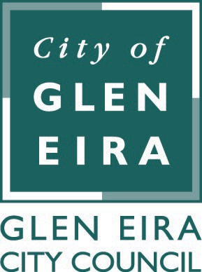

Terms of Reference
1. Name | Community Engagement Advisory Committee
2. Classification | Advisory Committee
3. Background | The Community Engagement Advisory Committee was originally formed as the Consultation Advisory Committee in 2009 to act as a steering committee to assist Council by providing recommendations in relation to reviewing, improving and broadening the ways Council engages and consults with all residents, ratepayers and other stakeholders.
4. Function and Role | To make recommendations to Council in relation to the ways in which Council engages and consults with residents,  ratepayers and other stakeholders in the community to ensure maximum participation, communication and value to the community.
5. Term of Committee | Ongoing
6. Membership and Term of Membership | - A minimum of three (3) Councillors  - Up to four community representatives  Councillors to be appointed annually by Council.  Council may appoint up to four (4) community representatives following advertising and assessment against agreed criteria. Any such appointment is for two years.
7. Chairperson and Term of Chairperson | Chairperson: A Councillor appointed by the Committee.
8. Voting Rights | Councillor members only.
9. Quorum | At least two (2) Councillors.
10. Conduct of Members | Meetings of the Committee will be treated as an Assembly of Councillors. Councillors’ Code of Conduct applies.  The conflict of interest and confidentiality provisions in the Local Government Act

 | 2020 apply to all members.
11. Role of Council Staff Attendee(s) | Executive Officers to the Committee  - Director Community Wellbeing  - Manager Community Development and Engagement
12. Meeting Frequency | As and when required.
13. Reporting Requirements | Advisory Committee minutes and recommendations to be submitted to the next appropriate Ordinary Council meeting for consideration.
14. Other Relevant Information | Council may cease a committee or update the Terms of Reference at any stage by Council Resolution.
15. Committee Contact Details | Director Community Wellbeing
16. Date of Council Approval of Terms of Reference | 26 November 2019
17. Date of Next Review of Terms of Reference | November 2021

