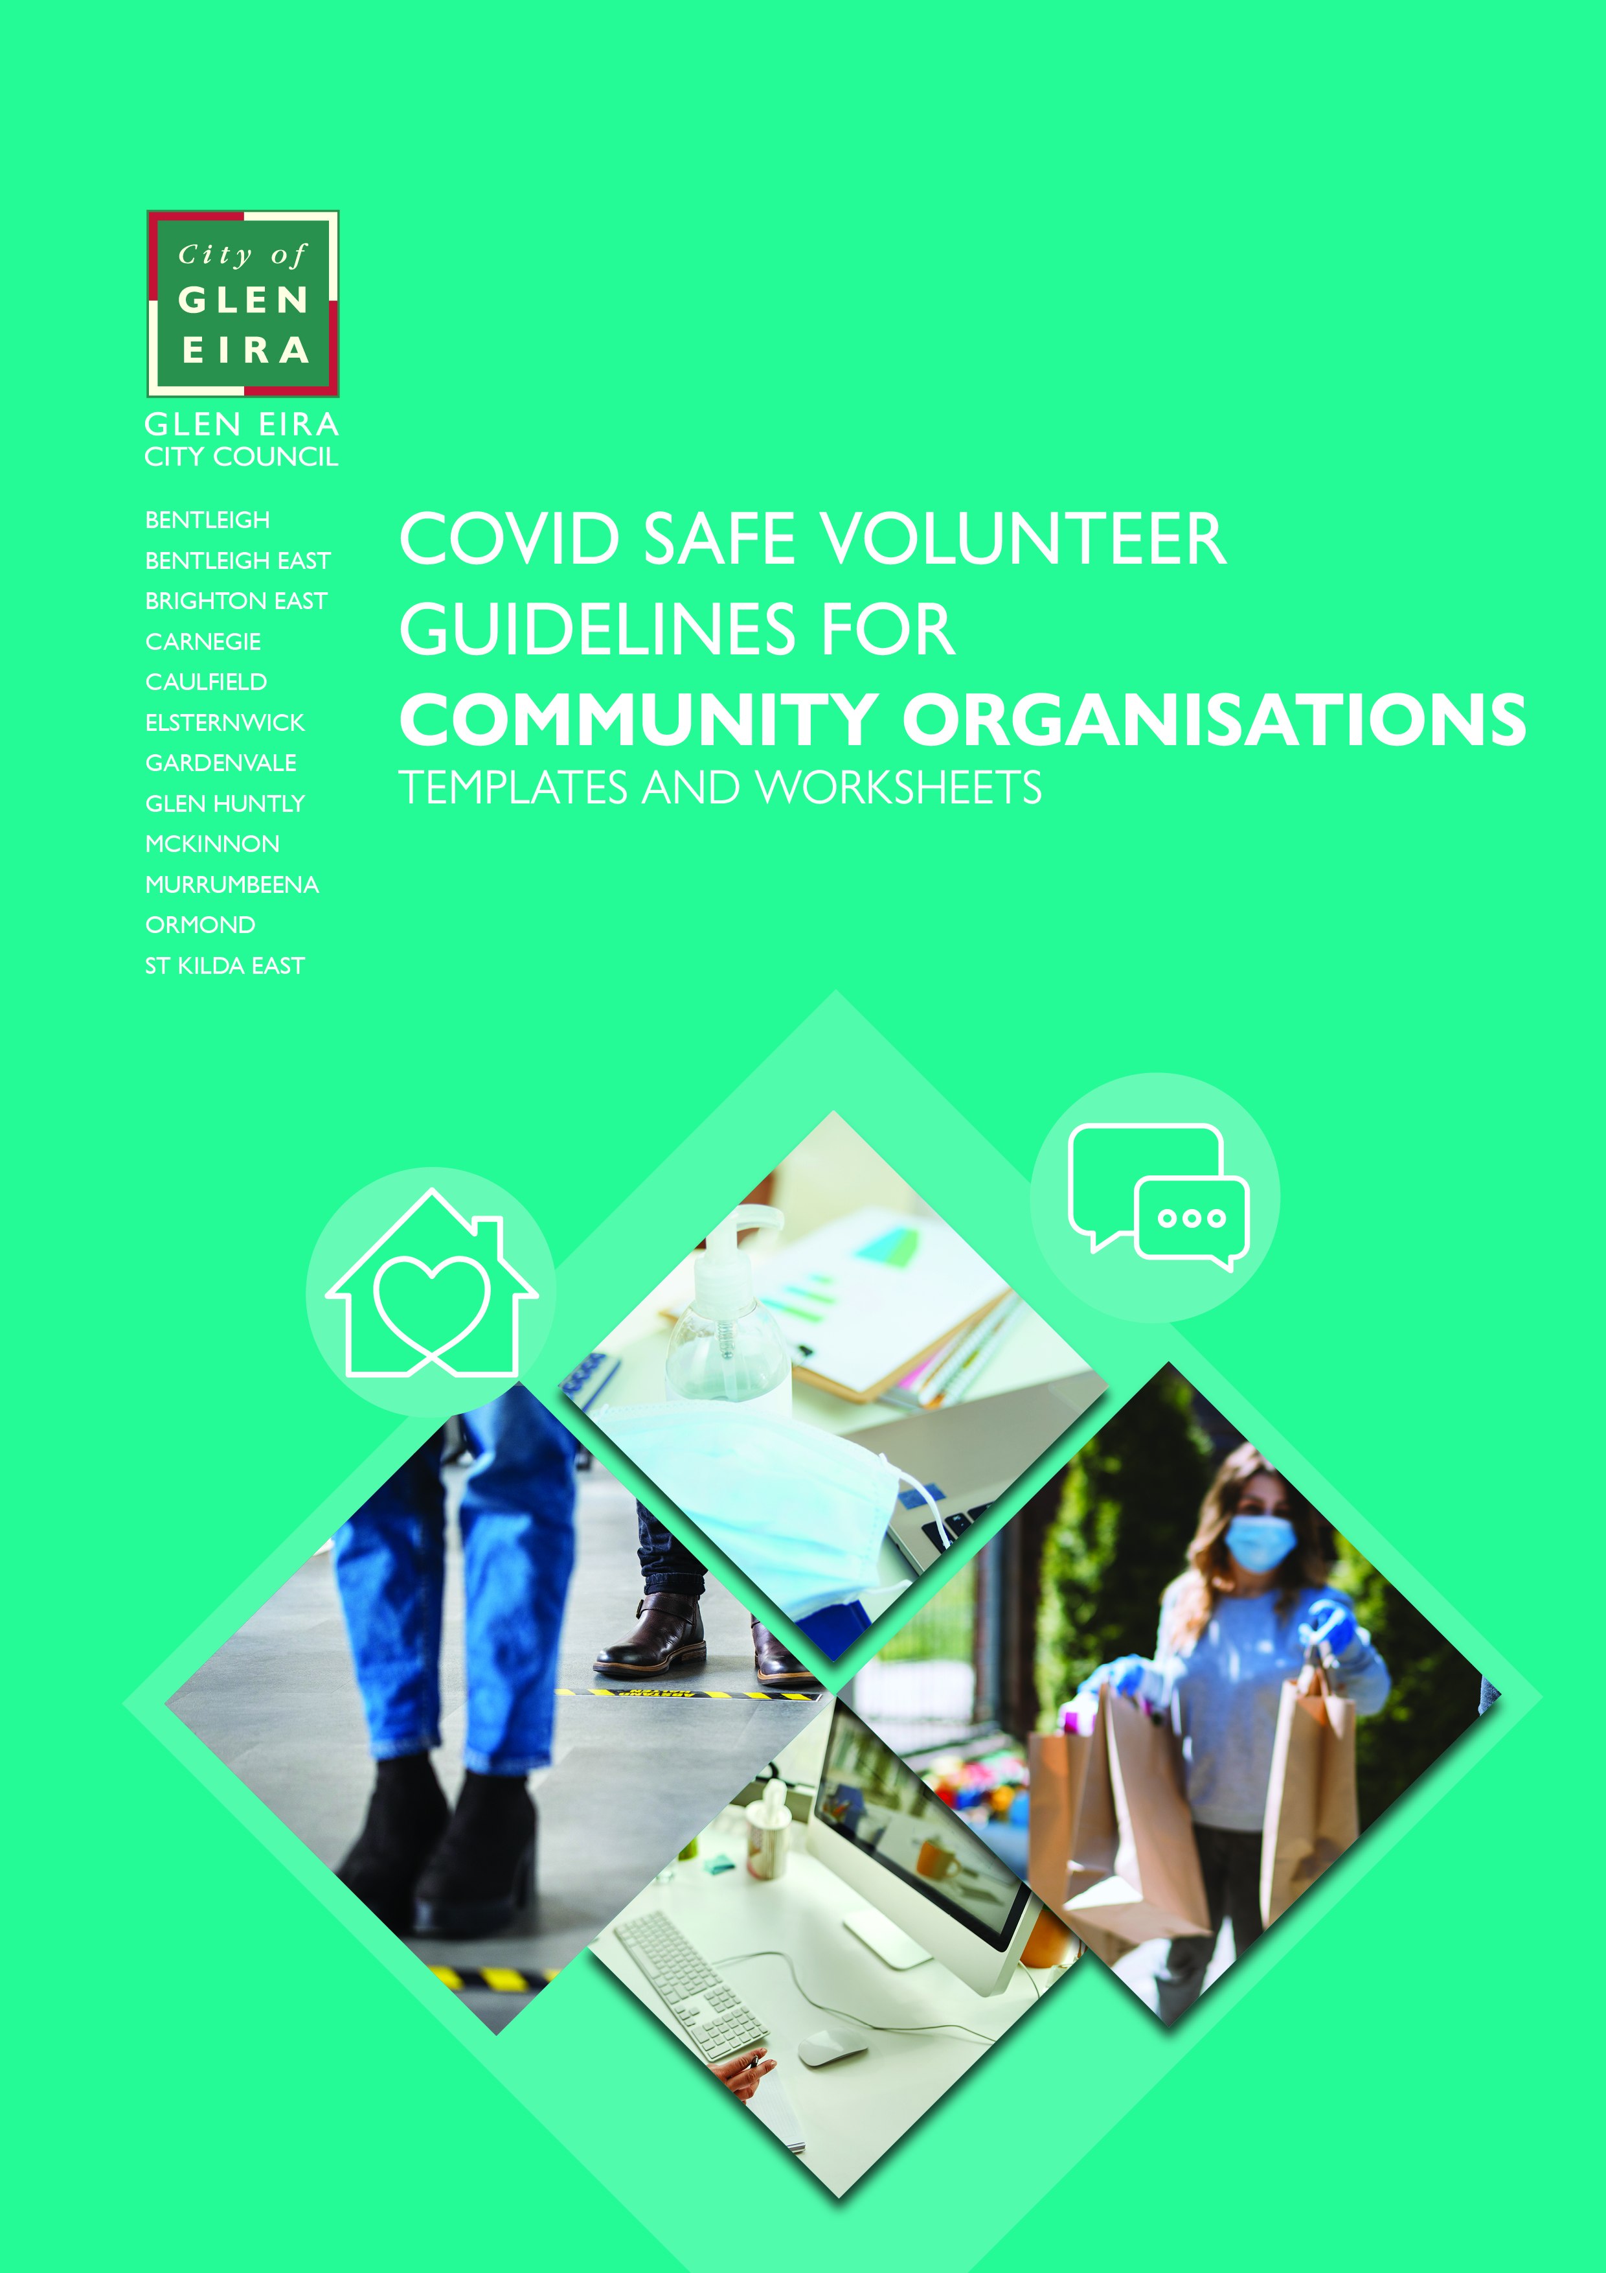
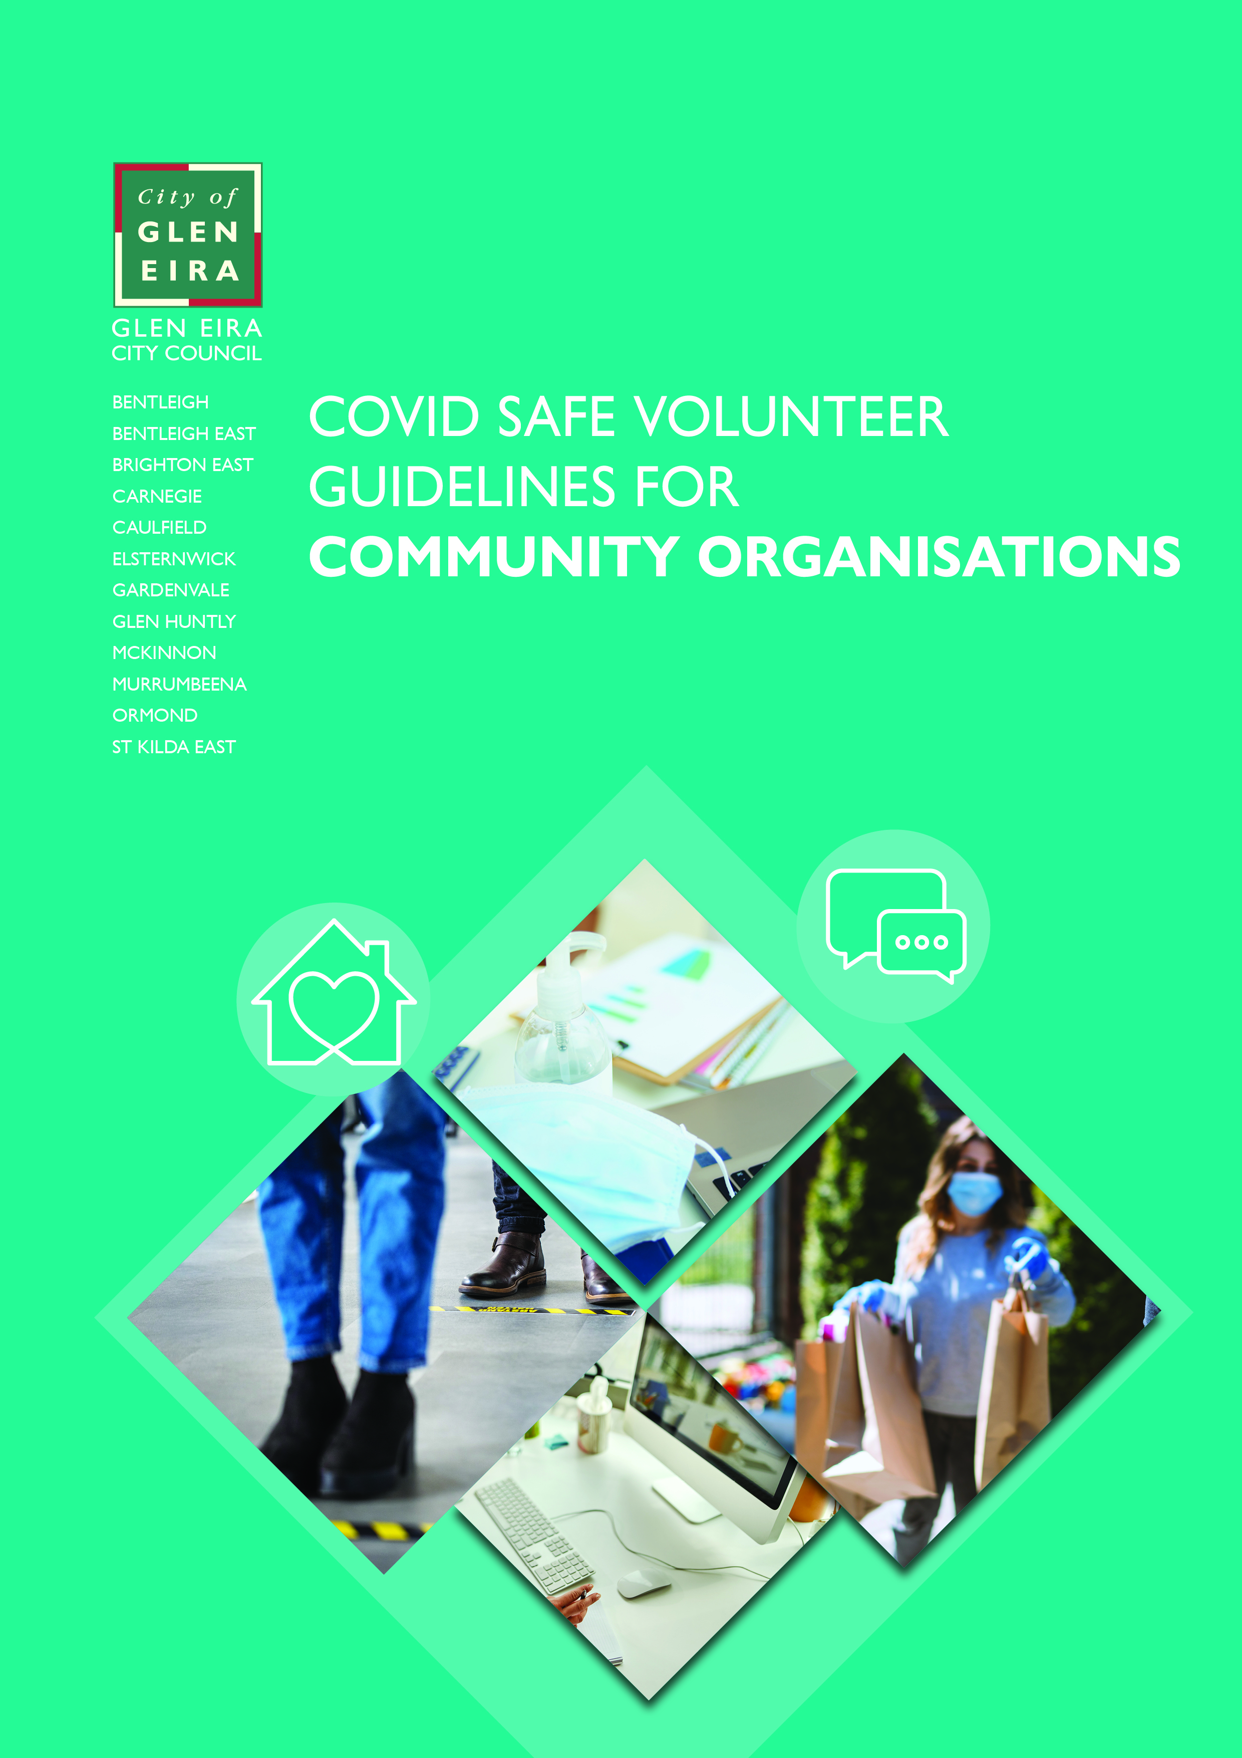

Table of Contents
Appendix 1.0 — Volunteer Program Status Worksheet 3
Appendix 2.0 — Volunteer Program Priorities Worksheet 4
Appendix 3.0 — Sample COVID-19 Risk Register — Safe Work Australia — general industry 5
Appendix 4.0 — Redesign Your Volunteer Program Worksheet 10
Appendix 5.0 — Volunteer Program Roles Worksheet 11
Appendix 6.0 – Sample Volunteer Position Description 12
Appendix 7.0 — Welcoming Volunteers Back Safely Checklist 13
Appendix 8.0 — Other useful resources 14

Appendix 1.0 — Volunteer Program Status Worksheet

Volunteer program | Roadmap step one | Roadmap step two | Roadmap  step three | Roadmap last step | Roadmap COVID normal
eg. Seniors exercise class | Status:  Continuing in a modified format — operating online from home  Restrictions: Closed — physical premises | Status:  Continuing in a modified format — operating online from home  Restrictions: Closed — physical premises | Status: Continuing in a modified format — operating online from home or the hall  Restrictions: Heavily restricted — streaming/recording of classes only. | Status:  Restart — modified format  Restrictions: Restricted — increased participant cap and density quotient | Status:  Restart — modified format  Restrictions: Open with a COVID safe plan — record keeping requirements and density quotient applies
<<Enter volunteer program name here>> | Status:  Select  Restrictions:  Select | Status:  Select  Restrictions:  Select | Status:  Select  Restrictions:  Select | Status:  Select  Restrictions:  Select | Status:  Select  Restrictions:  Select
<<Enter volunteer program name here>> | Status:  Select  Restrictions:  Select | Status:  Select  Restrictions:  Select | Status:  Select  Restrictions:  Select | Status:  Select  Restrictions:  Select | Status:  Select  Restrictions:  Select
<<Add additional volunteer programs if needed>>

Appendix 2.0 — Volunteer Program Priorities Worksheet

Program name: |  | <<enter program name here>>
Program elements | Roadmap step one | Roadmap step two | Roadmap step three | Roadmap last step | Roadmap COVID normal
<<Enter program element here>> | Select priority level | Select priority level | Select priority level | Select priority level | Select priority level
<<Enter program element here>> | Select priority level | Select priority level | Select priority level | Select priority level | Select priority level
<<Enter program element here>> | Select priority level | Select priority level | Select priority level | Select priority level | Select priority level
<<Enter program element here>> | Select priority level | Select priority level | Select priority level | Select priority level | Select priority level
<<Enter program element here>> | Select priority level | Select priority level | Select priority level | Select priority level | Select priority level

Appendix 3.0 — Sample COVID-19 Risk Register — Safe Work Australia — general industry

Location: Smith’s smallgoods
Date: 20/04/2020
Hazard | What is the harm that the hazard could cause? | What is the likelihood that the harm would occur? | What is the level of risk? | What controls are currently in place? | Are further controls required? | Actioned by | Date due | Date complete | Maintenance and review
COVID-19 from customers who are infected. | Staff or other customers catching COVID-19 (could result in serious illness or death). | Low. There have been few cases locally. | Moderate. While there are only a few local cases the consequences may be severe. | Cleaning and disinfecting in accordance with guidance from Safe Work Australia and public health authority.  Frequently touched surfaces including counters, handrails, doors, till, phones, keyboards and EFTPOS facilities are regularly cleaned.  Trolleys and hand baskets are wiped clean with surface wipes after each use.  Customers are requested to only touch items they are interested in purchasing.  Physical distancing — floor has markings to keep workers and customers at least 1.5m apart from each other. No more than 15 customers are allowed into the store at a time to allow for physical distancing and signs placed around the store advising of these rules.  Plexi glass screen is installed at counters. Customers are kept back from counters.  Payments only accepted via tap and go.  Alcohol-based hand sanitiser is provided at all workstations and on entry to the shop (out of reach of children).  Posters on hand washing are prominent in store and hand washing facilities are available in the bathrooms. | Encouraging online purchases and contactless delivery.  Customers who bring their own bags will be asked to pack them themselves. | John Smith | 30/04/2020 | Click here to enter a date. | Click here to enter text.
COVID-19 from staff who are infected. | Other staff or customers catching COVID-19 (could result in serious illness or death). | Low. There have been few cases locally. | Moderate. While there are only a few local cases the consequences may be severe. | Cleaning and disinfecting are done in accordance with guidance from Safe Work Australia and Health authorities.  Frequently touched surfaces including counters, handrails, doors, till, phones, keyboards and EFTPOS facilities have all been identified for regular cleaning.  Staff have been briefed on symptoms of COVID-19 and have been told to stay home if they aren’t feeling well.  If a staff member becomes unwell at work, a process is in place to isolate them and arrange for them to be sent home to receive medical attention.  Staff don’t have contact with delivery drivers, all paperwork is completed electronically.  Soap and water for hand washing and paper towel or air dryer for hand drying is available in bathrooms, break rooms, behind the deli counter and at back of shop with instructional signs on hand washing.  Alcohol-based hand sanitiser is also available in all staff areas including bathrooms, break rooms, the loading dock and delivery vehicles and signs are displayed on appropriate use.  Where staff meetings are required, they are held over the phone and information sent by email where possible.  Break times are staggered to minimise the number of staff using break room at one time.  Smith’s Smallgoods delivery van cleaned between swapping delivery drivers. | Update roster so staff are rostered with the same colleagues each shift to minimise exposure.  New automatic soap dispenser ordered from eBay. | Sally Smith | 30/04/2020 | Click here to enter a date. | Consult with workers at next staff meeting for any feedback on revised roster and effectiveness of new soap dispenser.
Fatigue from working longer hours to meet high demand. | Injury to staff or others form fatigue-related accidents or illness resulting from fatigue. | High. Demand has increased significantly, and most workers did overtime last week. | High. Particularly for staff doing deliveries or driving to and from work. | Ensure maximum shift lengths and maximum starts per week are observed to prevent fatigue.  Ensure breaks are provided.  Staff are rostered to ensure that they regularly get two complete days off work if they are working long hours,  Staff numbers reflect work required to deal with customer flow and stock replenishment.  Staff reporting feeling tired are sent home and driven or offered a taxi if necessary. | Update website to streamline service and reduce demand on staff.  Hire temporary staff to meet demand. | John Smith | 24/04/2020 | Click here to enter a date. | Click here to enter text.
Customer aggression | Physical or psychological injury to staff. | High. Customers concerned they may not get the goods they require have verbally abused staff twice in the last week. | High. Staff are already reporting instances of abuse and violent behaviour. | There is always a manager rostered on to assist but they often get caught up with other tasks.  There is a counter to physically separate staff, but they often need to leave it to restock shelves.  Managers regularly contact delivery drivers and are on call to address any customer concerns. Drivers can report aggressive customers and they may not be able to access the service in future.  Processes are in place to ban abusive and violent customers from the store or call police.  Staff have access to psychological support through an Employee Assistance Program. | Messages posted on the business website about shortages and when new stock is arriving.  Where goods aren’t available customers can pre-order from the next delivery.  Manager prioritises assisting staff with upset customers and staff able to remove themselves if they feel necessary.  Shelves restocked while store closed.  Clear signage in store  Training for workers on communicating with aggressive customers | Sally Smith | 20/04/2020 | 20/04/2020 | Review if any further occurrences reported or on 04/05/2020
New delivery service. | Vehicle accidents injuring staff or others. | Moderate. Based on the experience of similar businesses. | High. Injuries could be severe. | Van provided by the business is in good working order.  Staff are given familiarisation with the van before driving.  Staff licences checked before becoming delivery drivers. | Regular checks and maintenance scheduled for van. | Sally Smith | 22/04/2020 | Click here to enter a date. | Click here to enter text.
Persistent use of hand sanitizer. | Dermatitis | Moderate. Many staff will not have used hand sanitiser regularly before | Moderate. Affected individuals may have a significant reaction. | Staff are encouraged to wash hands with soap and water for 20 secs where possible as an alternative to hand sanitiser in non-medical situations. | Ask staff if they have a history of dermatitis or allergy to alcohol. | David Brown | 27/04/2020
Persistent use of latex gloves. | New or aggravated latex sensitivity. | Low. Most gloves will not be latex-based. | Moderate. Affected individuals may have a significant reaction. | Staff are provided with non-latex gloves or remove gloves when not necessary. | Ensure latex free gloves are purchased. | Lisa Singh | 24/04/2020
Click here to enter text. | Click here to enter text. | Click here to enter text. | Click here to enter text. | Click here to enter text. | Click here to enter text. | Click here to enter text. | Click here to enter a date. | Click here to enter a date. | Click here to enter text.

Appendix 4.0 — Redesign Your Volunteer Program Worksheet

Program name: |  | <<enter program name here>>
Ensure physical distancing | How are you ensuring workers and visitors are 1.5m apart as much as possible? | What is your density quotient and how are you meeting it? | How are you training your volunteers on the physical distancing expectations while working and socialising (including carpooling guidelines)? | Do you have any additional requirements to meet for your industry?
Wear a face covering | How are you ensuring all workers and visitors are wearing a face covering as per public health advice? | Are screens or barriers required for additional protection? | How are you going to train volunteers on how to correctly fit, use and dispose of PPE?
Practise good hygiene | Have you created a frequent and regular cleaning and disinfecting regime for shared spaces including high-touch communal items such as door handles, taps, light switches, telephones, etc? | Where are you displaying your cleaning log?  Who is responsible for filling it in? | How are you ensuring you provide soap and hand sanitiser throughout the worksite and encouraging regular handwashing/sanitisation? | Do you have any additional requirements to meet for your industry?
Keep records and act quickly if workers become unwell | How are you going to support volunteers to get tested and stay home even if they have mild symptoms? | Have you developed a contingency plan to manage outbreaks?  Where is it and how is it accessed? | How are you recording and storing records of all people who enter the workplace for contract tracing? | What screening system have you implemented upon entry into the workplace?  Do you have any additional requirements to meet for your industry?
Avoid interactions in enclosed spaces | How are you reducing the amount of time volunteers spend in an enclosed space? Eg. can meetings, lunchbreaks, etc. occur outside? | Can you enhance airflow by opening doors and windows? | Can you optimise airflow in your air-conditioning system?
Create workforce bubbles | Have you created rosters that keep groups of volunteers rostered on the same shifts at a single worksite and ensure there is no overlap of volunteers during shift changes? | Have you captured and kept records of all volunteers who have disclosed that they reside with another volunteer and ensured there is no crossover between shifts? | Do you have any additional requirements to meet for your industry?
Training/induction requirements | How are you going to train your volunteers on the new processes and procedures? | How are you going to induct your volunteers back into the workplace?
Communication requirements/ method | How are you going to communicate with your volunteers about returning, training, induction and ongoing announcements/changes? | How are you going to communicate with your clients/customers/ contractors about your new processes and operating procedures?
Other information

Appendix 5.0 — Volunteer Program Roles Worksheet

Program name: |  | <<enter program name here>>
<<enter volunteer role name>>: | <<enter volunteer role name>>: | <<enter volunteer role name>>: | <<enter volunteer role name>>: | <<enter volunteer role name>>:
- <<enter task/ responsibility>> | - <<enter task/ responsibility>> | - <<enter task/ responsibility>> | - <<enter task/ responsibility>> | - <<enter task/ responsibility>>
- <<enter task/ responsibility>> | - <<enter task/ responsibility>> | - <<enter task/ responsibility>> | - <<enter task/ responsibility>> | - <<enter task/ responsibility>>
- <<enter task/ responsibility>> | - <<enter task/ responsibility>> | - <<enter task/ responsibility>> | - <<enter task/ responsibility>> | - <<enter task/ responsibility>>
- <<enter task/ responsibility>> | - <<enter task/ responsibility>> | - <<enter task/ responsibility>> | - <<enter task/ responsibility>> | - <<enter task/ responsibility>>
- <<enter task/ responsibility>> | - <<enter task/ responsibility>> | - <<enter task/ responsibility>> | - <<enter task/ responsibility>> | - <<enter task/ responsibility>>
- <<enter task/ responsibility>> | - <<enter task/ responsibility>> | - <<enter task/ responsibility>> | - <<enter task/ responsibility>> | - <<enter task/ responsibility>>
- <<enter task/ responsibility>> | - <<enter task/ responsibility>> | - <<enter task/ responsibility>> | - <<enter task/ responsibility>> | - <<enter task/ responsibility>>
- <<enter task/ responsibility>> | - <<enter task/ responsibility>> | - <<enter task/ responsibility>> | - <<enter task/ responsibility>> | - <<enter task/ responsibility>>

Appendix 6.0 – Sample Volunteer Position Description

Name of volunteer:
Position title:
Organisation name:
Name of department or unit:
Location of position:
Start date:
End date (if short-term assignment):
Hours and days required per week (if applicable):
Reports to:
Role or project overview and purpose — and how it relates to the organisation’s mission and other projects:
Key responsibilities:
Skills, experience and attributes:
Training requirements:
Benefits for the volunteer:
Benefits to volunteer’s employer (if applicable):
Other requirements of the role:
Any other special conditions (describe)
Any other training required (describe)
Medical check
Police check
Induction training
Volunteer manager signature:
Volunteer signature:
Date:
Date of position description review:

Appendix 7.0 — Welcoming Volunteers Back Safely Checklist
https://www.volunteeringvictoria.org.au/wp-content/uploads/2020/06/Welcoming-Volunteers-Back-Safely-Checklist.pdf

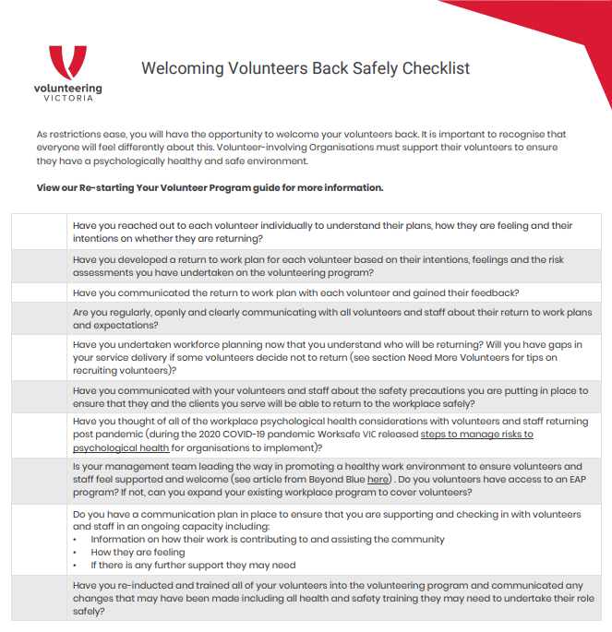

Appendix 8.0 — Other useful resources
Tailor the below register to your premises (add/delete/rename rows as appropriate) and ensure the cleaning instructions are appropriate for your industry.
Cleaning Register — high touch surfaces — <<INSERT DATE>>
Clean at least once per day or at the end of each shift with a soap and water solution followed by a disinfectant (alcohol in a concentration of at least 70 per cent, chlorine bleach in a concentration of 1,000 parts per million, oxygen bleach or wipes/sprays that contain quaternary ammonium compounds (follow product labels for dilution instructions). Alternatively, you may be able to do a two-in-one clean and disinfection by using a combined detergent and disinfectant.
Cleaners are to follow product labels and wear the appropriate protective equipment and then record the date, time, their initials and tick the box next to each surface they clean. Place a X next to any surface not cleaned.
Date:
Time:
Cleaner initials:
Entry
Door handles/plates
Railings
Counters
Telephones
Elevator buttons
Light switches
EFTPOS machines
Office
Door handles/plates
Light switches
Desks
Keyboard/mouse
Telephones
Printer/photocopier
Cupboard handles
Male Bathroom
Door handles/plates
Light switches
Toilets incl. buttons, seats
Urinal incl. buttons
Taps
Vanity
Female Bathroom
Door handles/plates
Light switches
Toilets incl. buttons, seats
Taps
Vanity
Kitchen
Door handles/plates
Light switches
Bench surfaces/tabletops
Taps
Fridge front/handles
Microwave door/buttons
Coffee Machine buttons
Kettle handle, lid, button
Toaster button
Cupboard handles
Other
Door handles/plates
Light switches
Air conditioner controls
Remote controls

