IMS Booking system
User guide

About this program
The program is used to manage bookings, collating all the required paperwork and data to allow council to manage clashes and approve bookings.
Table of Contents

About this program 2
Logging on 3
Update your contact details 4
Casual bookings Error! Bookmark not defined.
Completing an application for casual use 4
Once your application is submitted 6

Logging on
This program is cloud based and can be accessed from any computer or device with internet connection. You will need to set up an account with your unique username and password.
Tip: Save www.imscomply.com.au in your email system as “not junk” to ensure you receive these notifications.
Step 1
Cut and paste the program URL supplied into your preferred internet browser.

Step 2  Select Create account. Fill out required information and select Register. | 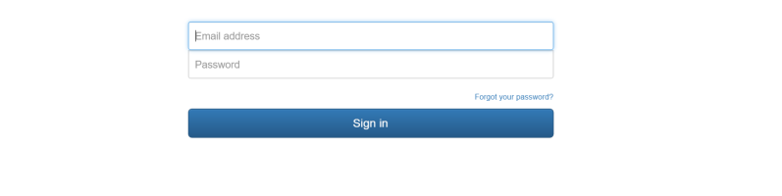
Step 3  An email will be sent to your email address. Click on the link per email to validate and activate your account. | 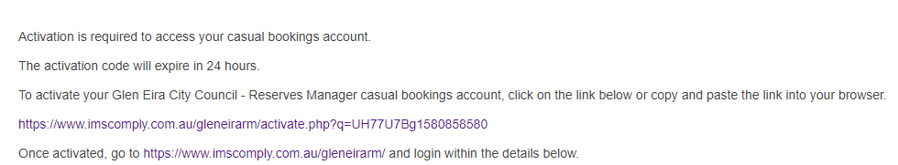
Step 4
Your email will become your username, select a password and sign in.

Update your contact details
About | How to
Update contact details  You can keep your key contact’s details up to date in this area including:  - Contact details  - Password and email | Always ensure there is a valid email address entered, so email alerts can be received and attended to. If you change your email address, your username will change to reflect this.  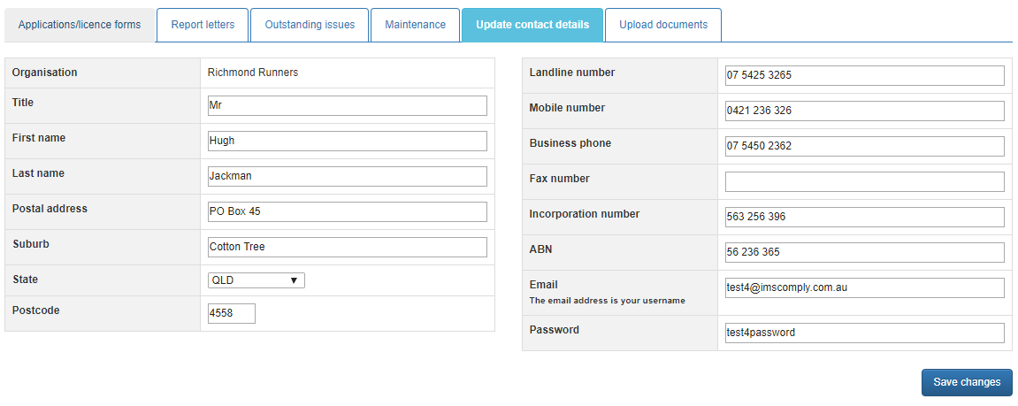  Click on save changes if any edits are made.

Open Space and rotunda booking
About | How to
Check availability for the date you are interested in or if you have already checked the availability of the date – start application | 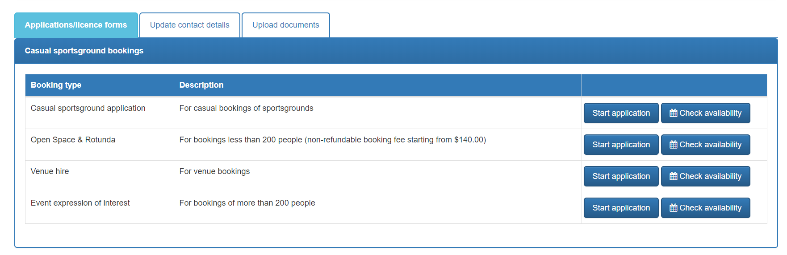

About | How to
Booking information  Select the park and rotunda and provide details on your needs.  Complete application form. | 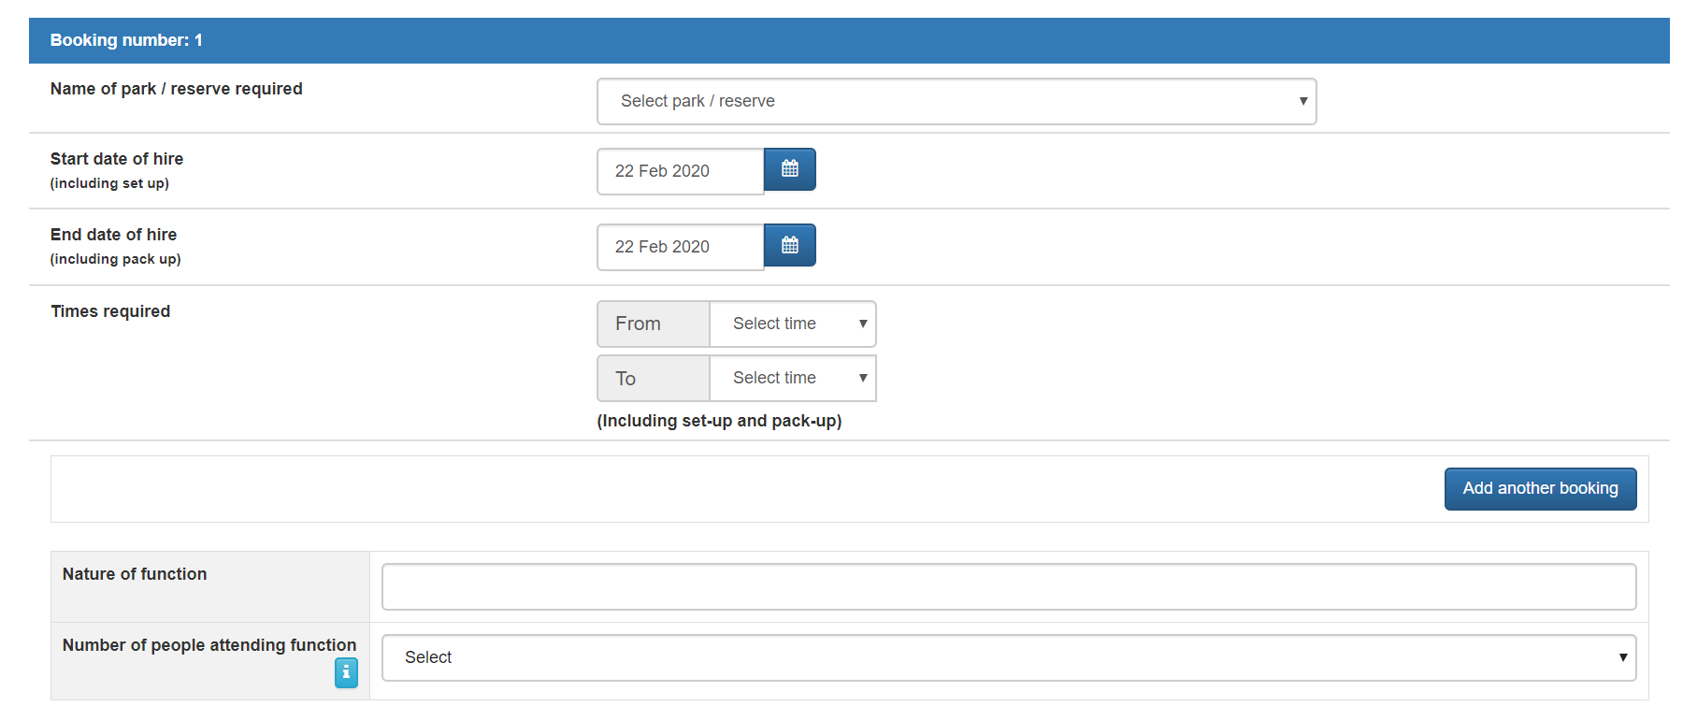
Public Liability Certificate  You will be required to upload this document. | If you are hiring a third party (entertainer etc) you will need to include a copy of their public liability insurance. Click on upload to add document to the application and enter an expiry date. 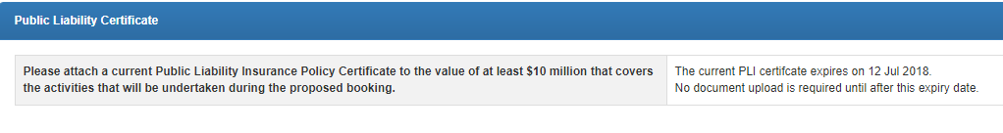
Will liquor be consumed  If there are 40 or more people in your group and at least one person will be consuming alcohol – you require written permission from Council | 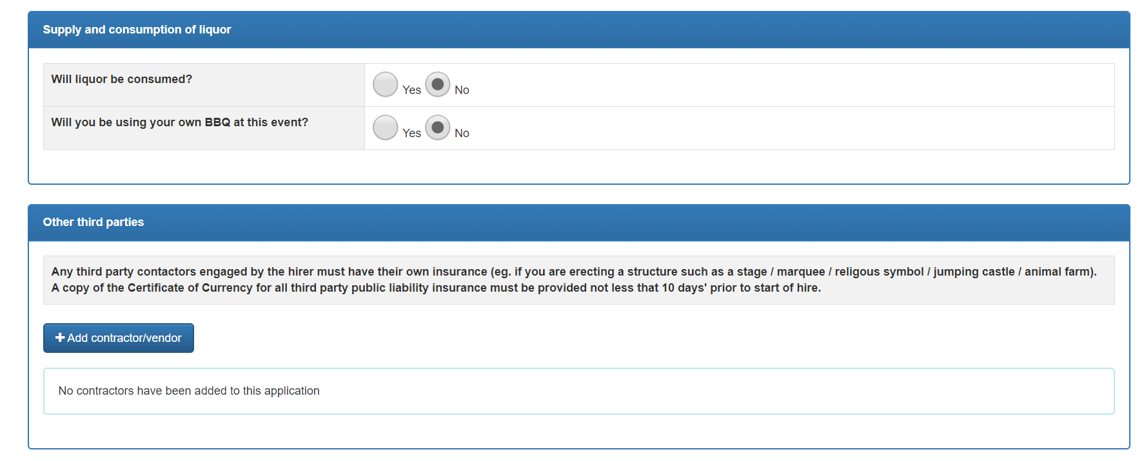

About | How to
Terms and conditions  Read terms and conditions. | Click on the T&C PDF to read. This must be opened before the applicant can submit the application.
Submit application  When all required fields have been entered and the Terms and Conditions opened and agreed to via the checkbox, the Submit Application icon will be available. | Tick the checkbox agreeing to the terms and conditions. Submit application.  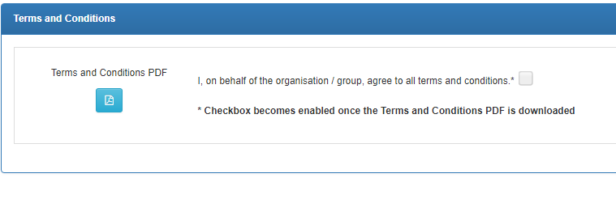  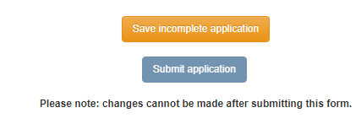

Once your application is submitted
Council will receive your application and either approve your booking, reset your application to make changes, or reject your booking. You will be notified by email and can view the status of your application in the Applications/licence forms tab. An invoice will be sent for payment to secure the booking.
If you have any further queries, please contact the Open Space Bookings Officer on recservices@gleneira.vic.gov.au or 9524 3333.

