Planning and Environment Act 1987

GLENEIRA PLANNING SCHEME

AMENDMENT C197glen

EXPLANATORY REPORT

Who is the planning authority?
This amendment has been prepared by the Glen Eira Council which is the planning authority for this amendment.
The Amendment has been made at the request of Glen Eira Council.

Land affected by the Amendment
The Amendment applies to the Field Street Precinct, Bentleigh. This includes:
- Field Street: 1-37 (odd), 2-30 (even)
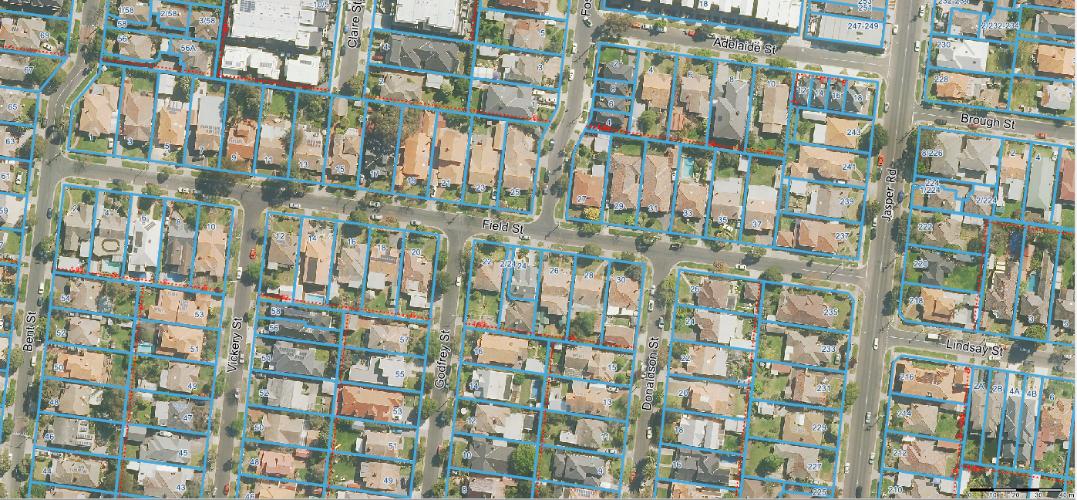
A mapping reference table is attached at Attachment 1 to this Explanatory Report.

What the amendment does
The Amendment proposes to apply a Heritage Overlay to the Field Street Precinct (HO188).
Specifically the amendment seeks to:
- Amend the Schedule to Clause 43.01 - Heritage Overlay to include HO188;
- Amend Schedule 4 to Clause 43.02 - Design and Development Overlay to remove reference to the Field Street character area;
- Amend Schedule 3 Clause 43.05 - Neighbourhood Character Overlay to remove reference to the Field Street character area;
- Amend the Schedule to Clause 72.04 to include the Statement of Significance for HO188;
- Amend Map No. 3HO to apply a Heritage Overlay HO188.
- Amend Map No.3NCO to delete the Neighbourhood Character Overlay (NCO3).
- Amend Map no. 3DDO to delete the Design and Development Overlay (DDO4).

Strategic assessment of the Amendment

Why is the Amendment required?
Council engaged heritage consultants, Built Heritage Pty Ltd to review the Field Street area to ascertain its heritage value. The significance of the precinct was assessed against the standard criteria contained within Planning Practice Note 01 Applying the Heritage Overlay (August 2018) and is considered to meet the requirements and threshold for local protection through the Heritage Overlay. A heritage citation was adopted by Council on 24 September 2019. The Citation for Field Street Precinct confirms the precinct meets the threshold for local significance and satisfies Criterion A (historic significance) and Criterion E (aesthetic significance). Amendment 197glen is required to implement the findings of the citation.
The Field Street area has an existing Neighbourhood Character Overlay (NCO3) and Design and Development Overlay (DDO4) applied. The NCO is used when an area exhibits specific characteristics that need to be protected or changed to achieve a preferred character and the DDO relates to specific design and development outcomes sought. Whereas a Heritage Overlay is used when a place has cultural heritage value and the objective is to conserve the existing building or buildings. With respect to Field Street, a heritage consultant has confirmed that the precinct meets the threshold for local heritage significance. Inclusion of the precinct within the Heritage Overlay will also ensure protection of the existing neighbourhood character. It is therefore appropriate to remove the existing NCO and DDO as these controls are seen to be an unnecessary additional layer of control to the area.

The Heritage Overlay is considered the most appropriate planning mechanism to protect the heritage values of this precinct.

How does the Amendment implement the objectives of planning in Victoria?
The Amendment is consistent with the objectives of planning in Victoria, in particular the objective detailed in Section 4(1) (d) of the Planning and Environment Act 1987, being:
To conserve and enhance those buildings, areas or other places which are of scientific, aesthetic, architectural or historical interest, or otherwise of special cultural value.
The heritage values associated with the Field Street Precinct are outlined within the Statement of Significance for the precinct and will become an Incorporated Document.

How does the Amendment address any environmental, social and economic effects?
The amendment is expected to have positive environmental effects by protecting a precinct identified as having cultural heritage significance in Glen Eira.
The amendment is expected to have positive social effects by ensuring any future development responds to the heritage significance, so it can be appreciated by future generations.
There may be limited economic effects for landowners in terms of development considerations. However the wider economic benefits of retaining an intact group of historic commercial premises will result in net community benefit for the wider community of Glen Eira.

Does the Amendment address relevant bushfire risk?
The amendment does not impact on bushfire risk.

Does the Amendment comply with the requirements of any Minister’s Direction applicable to the amendment?
The amendment is consistent with the Ministerial Direction on the Form and Content of Planning Schemes under section 7(5) of the Planning and Environment Act 1987.
The amendment is consistent with Ministerial Direction No. 9 - Metropolitan Planning Strategy which requires amendments to have regard to Plan Melbourne.
The amendment is consistent with Direction 4.4 of Plan Melbourne: Respect Melbourne’s Heritage as we build for the future, which recognises the contribution heritage places make to Melbourne’s distinctiveness and liveability and advocates for the protection of Melbourne’s heritage places. Policy 4.4.1 recognises the need for ‘continuous identification and review of currently unprotected heritage sites…’.
The amendment is not considered to compromise the implementation of the Metropolitan Planning Strategy.
The amendment is consistent with Ministerial Direction 11 – Strategic Assessment of Amendments.

How does the Amendment support or implement the Planning Policy Framework and any adopted State policy?
The amendment supports the State Planning Policy Framework as follows:
Clause 15 – Built Environment and Heritage - Clause 15.03-1S Heritage Conservation
Objective
- To ensure the conservation of places of heritage significance.
Strategies
- Identify, assess and document places of natural and cultural heritage significance as a basis for their inclusion in the planning scheme.
- Retain those elements that contribute importance to the heritage place.
- Encourage appropriate development that respects places with identified heritage values.

How does the Amendment support or implement the Local Planning Policy Framework, and specifically the Municipal Strategic Statement?
The amendment supports the Municipal Strategic Statement as follows:
Clause 21.10 – Heritage
Objectives
- To identify, protect, enhance and promote understanding of Glen Eira’s heritage.
Strategies
- Protect places identified as having architectural, cultural or historical significance.

The amendment supports the Local Planning Policy Framework as follows:
Clause 22.01 – Heritage Policy
Objectives
- To protect places identified as having architectural, cultural or historic significance and which demonstrate the various eras of Glen Eira’s development.
- To encourage retention, preservation and restoration of all significant and contributory places within the City of Glen Eira.
The area has been assessed and found of be of local heritage significance.

How does the amendment support or implement the Municipal Planning Strategy?
N/A

Does the Amendment make proper use of the Victoria Planning Provisions?
The Heritage Overlay is the most appropriate mechanism for recognising and protecting the cultural heritage significance of the identified heritage places.

How does the Amendment address the views of any relevant agency?
The views of relevant agencies will be sought through the public exhibition of the amendment.

Does the Amendment address relevant requirements of the Transport Integration Act 2010?
The amendment is not expected to have any significant impact on the transport system.

Resource and administrative costs

It is not expected that the new planning provisions will have any significant impact on the resource and administrative costs of the responsible authority.

Where you may inspect this Amendment
The Amendment is available for public inspection, free of charge, during office hours at the following places:
Glen Eira City Council
Corner Glen Eira and Hawthorn Roads
CAULFIELD VIC 3162
The Amendment can also be inspected free of charge at Glen Eira Council website at www.gleneira.vic.gov.au/fieldstreet or the Department of Environment, Land, Water and Planning website at www.planning.vic.gov.au/public-inspection.

Submissions
Any person who may be affected by the Amendment may make a submission to the planning authority. Submissions about the Amendment must be received by 5:00pm on 2 March 2020.
A submission must be sent to:

Online submissions are preferred via:
www.gleneira.vic.gov.au/fieldstreet
Or by mail to:
Glen Eira Planning Scheme C197glen
Glen Eira City Council
PO Box 42
CAULFIELD SOUTH VIC 3162

Panel hearing dates
In accordance with clause 4(2) of Ministerial Direction No.15 the following panel hearing dates have been set for this amendment:
- directions hearing: 18 May 2020
- panel hearing: 6 July 2020

ATTACHMENT 1 - Mapping reference table

Location | Land /Area Affected | Mapping Reference
Glen Eira | Field Street, Bentleigh: 1-37 (odd), 2-30 (even) | 001hoMap03
Glen Eira | Field Street, Bentleigh: 1-37 (odd), 2-30 (even), 26 Donaldson Street and 235, 237 Jasper Road. | 003d-ddoMap03
Glen Eira | Field Street, Bentleigh: 1-37 (odd), 2-30 (even), 26 Donaldson Street and 235, 237 Jasper Road. | 002d-ncoMap03

