Statement of Significance: Field Street Precinct, Bentleigh (2019)

Address: | Field Street: 1-37 (odd), 2-30 (even) | Name: | Field Street
Place Type: | Residential | Grading: | Significant
PS ref no: | HO188 | Constructed: | Circa 1925-1949

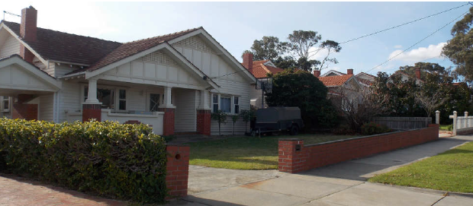

What is significant?
The Field Street Precinct, encapsulating properties at 1-37 and 2-30 Field Street, Bentleigh, comprises 35 detached dwellings along both sides of the street. This building stock consists almost entirely of single-storey brick and timber houses from the mid-1920s to the late 1930s; two more houses in similar styles appeared in the late 1940s, while the sole property of more recent origin is a pair of strata titled 1990s dwellings at No 24/24a.
Field Street forms part of the large and ambitious Garfield Estate, a 221-lot residential subdivision extending between Jasper Road and the railway line, created in 1924 from the former market gardens of the eponymous Garfield Brothers.

How is it significant?
The Field Street Precinct satisfies the following criteria for inclusion on the heritage overlay schedule to the City of Glen Eira planning scheme:
- Criterion A: Importance to the course, or pattern, of Glen Eira’s cultural history.
- Criterion E: Importance in exhibiting particular aesthetic characteristics.

Why is it significant?
The Field Street Precinct is associated with the Garfield Estate, a substantial residential subdivision that was laid out in 1924 and developed rapidly over the next fifteen years. Comprising more than two hundred allotments, the Garfield Estate was one of the largest and most ambitious of several local residential subdivisions created in the 1920s from former market gardens, taking advantage of the electrification of the railway line in 1922. The houses along Field Street, two of which date back as far as 1926, represent the most intact cluster of original pre-war residences within the entire extent of the Garfield Estate. (Criterion A)
The Field Street Precinct is significant as a notably intact inter-war residential streetscape in Bentleigh. Most houses, dating from c1925 to c1935, are demonstrative of the prevailing bungalow idiom of the time: single-storey detached brick or timber dwellings with tiled roofs and asymmetrical facades with front porches. Unified by a consistency of form and materials, they also show individuality through different window, porch and decorative treatments. They are complemented by slightly later brick houses in the Tudor Revival and Moderne idioms. Consistent in scale, form, setback and materials, the houses in Field Street combine to form cohesive inter-war residential streetscape that represents a rare survivor in the Bentleigh area. This is enhanced by their setting, including front gardens with open lawns, garden beds and low plantings along street boundaries, many of which are marked by brick or timber fences that, if not original, are evocative of the inter-war era. (Criterion E)

Primary source
Citation: Field Street Precinct, Bentleigh, prepared by Simon Reeves, Built Heritage Pty Ltd, 8 August 2019

