Planning and Environment Act 1987

GLEN EIRA PLANNING SCHEME

Notice of the preparation of an amendment

Amendment C197glen

The Glen Eira City Council has prepared Amendment C197glen to the Glen Eira Planning Scheme.

The land affected by the amendment is 1-31, 33, 35 and 37 Field Street, Bentleigh and as shown on the map below:

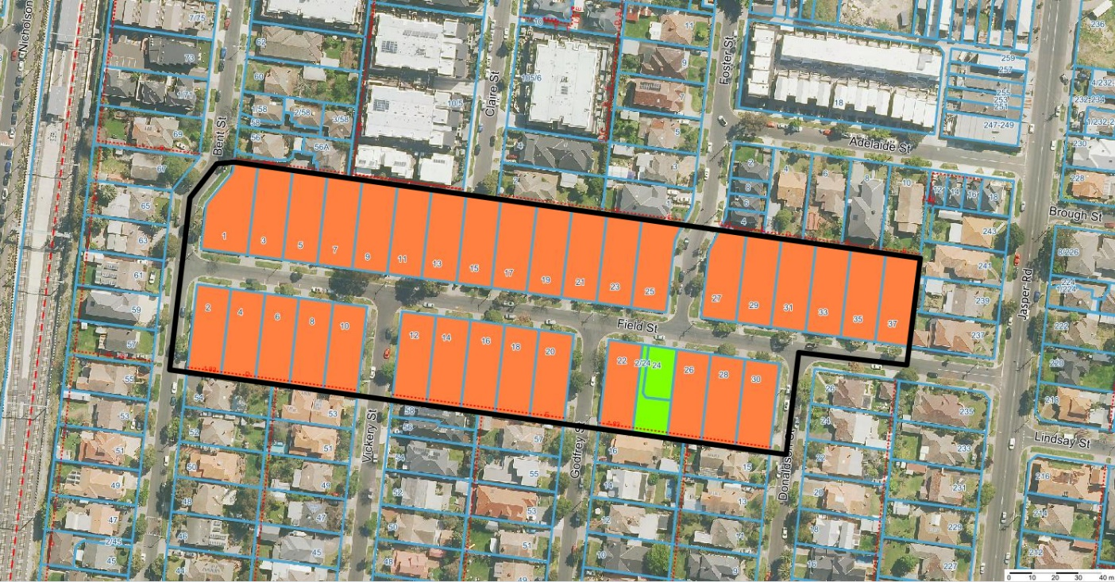
LEGEND:
Amendment boundary
Proposed contributory heritage significance
Proposed non-contributory heritage significance

The amendment proposes to apply a Heritage Overlay (HO188) to the land.

The amendment also seeks to:
- Amend the Schedule to Clause 43.01 - Heritage Overlay to include HO188;
- Amend Schedule 4 to Clause 43.02 - Design and Development Overlay to remove reference to the Field Street character area;
- Amend Schedule 3 Clause 43.05 - Neighbourhood Character Overlay to remove reference to the Field Street character area;
- Amend the Schedule to Clause 72.04 to include the Statement of Significance for HO188;
- Amend Map No. 3HO to apply a Heritage Overlay HO188 as per the attached map.
- Amend Map No.3NCO to delete the Neighbourhood Character Overlay (NCO3) as per the attached map.
- Amend Map no. 3DDO to delete the Design and Development Overlay (DDO4) as per the attached map.

You may inspect the amendment, any documents that support the amendment and the explanatory report about the amendment, free of charge, at the following locations:

- during office hours, at the office of the planning authority, Glen Eira City Council, corner of Hawthorn Road, and Glen Eira Road, Caulfield;
- at Council’s website https://www.gleneira.vic.gov.au/fieldstreet-heritage
- at the Department of Environment, Land, Water and Planning website www.delwp.vic.gov.au/public-inspection.

Any person who may be affected by the amendment may make a submission to the planning authority about the amendment. Submissions must be made in writing giving the submitter’s name and contact address, clearly stating the grounds on which the amendment is supported or opposed and indicating what changes (if any) the submitter wishes to make.

Name and contact details of submitters are required for council to consider submissions and to notify such persons of the opportunity to attend council meetings and any public hearing held to consider submissions. The closing date for submissions is 2 March 2020. A submission must be lodged online or sent to the Glen Eira City Council, PO Box 42, Caulfield South VIC 3162.

The planning authority must make a copy of every submission available at its office for any person to inspect free of charge for two months after the amendment comes into operation or lapses.

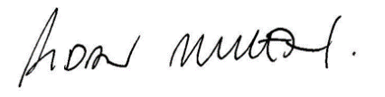
AIDAN MULLEN
MANAGER CITY FUTURES

