SCHEDULE 2 TO clause 37.02 COMPREHENSIVE DEVELOPMENT ZONE
--/--/20--
Proposed C155
Shown on the planning scheme map as CDZ2
EAST VILLAGE COMPREHENSIVE DEVELOPMENT PLAN
Land
This schedule applies to the land located at the corner of East Boundary Road and North Road in Bentleigh East as defined by the “East Village Comprehensive Development Plan, December 2018” as incorporated in this scheme. The land is shown on the planning scheme maps as CDZ2.
Plan 1 to Schedule 2 to Clause 37.02

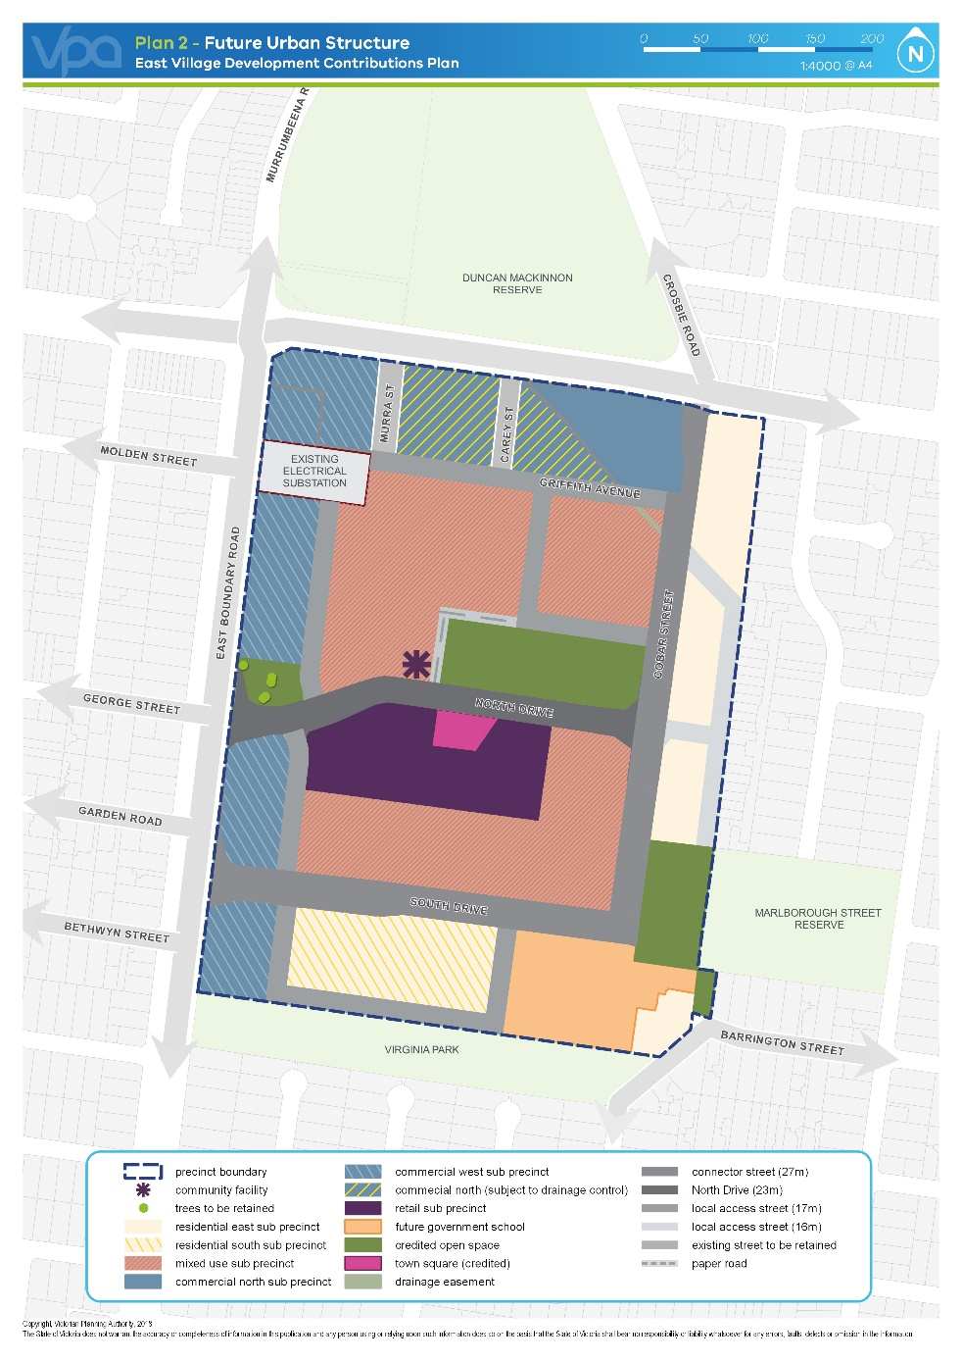
Note: This plan is a reproduction of Plan 1 Future Urban Structure as contained within the East Village Comprehensive Development Plan, December 2018.

Purpose
To facilitate a transition in land use from industrial to mixed use.
To encourage high quality urban design and architecture that is environmentally sustainable, responsive to its environs, improves local accessibility and permeability through the precinct, and provides active edges throughout the precinct.
To create a vibrant, safe, diverse and attractive public environment.
To encourage the intensive development of the land for a mix of uses including retail, residential, office, education, community and civic.
To ensure that new sensitive uses do not unreasonably impact on the ongoing operations of existing industrial uses as the land use mix within the precinct transitions.
1.0 Table of uses
--/--/20--
Proposed C155
Section 1 - Permit not required
Use | Condition
Accommodation (other than Corrective institution and Residential hotel) | Must be located in a residential sub-precinct as shown on Plan 1; or  Must be located in a mixed use sub-precinct or retail sub-precinct as shown on Plan 1:  -with any frontage at ground floor level not exceeding 4 metres  -must be located on the second floor or above.  Must be no more than 3,000 dwellings in the precinct boundary shown in Plan 1.
Animal keeping (other than Animal  boarding) | Must be no more than 2 animals.
Art and craft centre  Child care centre  Education centre  Exhibition centre | Must not be located in a residential sub-precinct as shown on Plan 1.
Home based business
Industry (other than Transfer station) | Must be located in a mixed use sub-precinct or commercial north sub-precinct or commercial north sub-precinct (subject to drainage controls) as shown on Plan 1.  Must not be a purpose listed in the table to Clause 52.10.
Informal outdoor recreation
Minor utility installation
Medical centre | The gross floor area must not exceed 250 square metres if located in a residential sub-precinct as shown on Plan 1.
Office (other than Medical centre) | Must not be located in a residential sub-precinct as shown on Plan 1.
Place of worship | Must not be located in a residential sub-precinct as shown on Plan 1.  The gross floor area of all buildings must not exceed 250 square metres.
Research centre | Must not be located in a residential sub-precinct as shown on Plan 1.
Restricted recreation facility | Must not be located in a residential sub-precinct as shown on Plan 1.  The gross floor area of all buildings must not exceed 500 square metres.
Retail premises (other than Adult sex product shop and Trade supplies) | Must be located in the retail sub-precinct as shown on Plan 1; or  Must be located in a mixed use sub-precinct as shown on Plan 1 with a leasable floor area not exceeding 150 square metres.
Veterinary centre | Must not be located in a residential sub-precinct as shown on Plan 1.  The gross floor area of all buildings must not exceed 250 square metres.
Warehouse | Must be located in a mixed use sub-precinct, commercial north sub precinct, or commercial north (subject to drainage controls) as shown on Plan 1.  Must not be a purpose listed in the table to Clause 52.10.
Any use listed in Clause 62.01 | Must meet the requirements of Clause 62.01.
Section 2 - Permit required
Use | Condition
Accommodation (other than Corrective institution and Residential hotel) where the Section 1 condition is not met | Must not be located in commercial north, or commercial north (subject to drainage controls) or commercial west sub precinct as shown on Plan 1.
Industry (other than Transfer station) where the section 1 conditions are not met | Must not be located in a residential sub-precinct or commercial west sub precinct as shown on Plan 1.
Trade supplies | Must be located in commercial north sub-precinct or commercial north (subject to drainage controls) as shown on Plan 1.
Leisure and recreation (other than Informal outdoor recreation and Indoor recreation facility) | Must not be located in a residential sub-precinct as shown on Plan 1.
Place of assembly (other than Exhibition centre and Place of worship)
Residential hotel
Retail premises (other than Adult sex product shop, and Trade supplies) where the section 1 conditions are not met | Must not be located in a residential sub-precinct as shown on Plan 1.
Any other use not in Section 1 or 3
Section 3 - Prohibited
Use
Adult sex product shop
Brothel
Corrective institution
Transfer station
Stone extraction
Major sport and recreation facility
Motor racing
2.0 Use of land
--/--/20--
Proposed C155
Requirements
The use of land must be generally in accordance with the East Village Comprehensive Development Plan, December 2018.
Amenity of the neighbourhood
A use must not detrimentally affect the amenity of the neighbourhood, including through the:
- Transport of materials, goods or commodities to or from the land.
- Appearance of any building, works or materials.
- Emission of noise, artificial light, vibration, smell, fumes, smoke, vapour, steam, soot, ash, dust, waste water, waste products, grit or oil.
Application requirements
The following application requirements apply to an application for a permit to use land in addition to those specified in Clause 37.02 and elsewhere in the scheme and must accompany an application, as appropriate, to the satisfaction of the responsible authority.
- The purpose of the use and the types of activities which will be carried out.
- The likely number of employees.
- The likely effects of the use on the local and regional traffic network;
- The works, services or facilities required to cater for those effects so that the efficiency and safety of the traffic network is maintained; and
- The proposed method of funding the required works, services or facilities.
- The availability and capacity of the electricity, drainage, sewer water and digital networks; and
- Any necessary upgrades to those networks; and
- The proposed method of funding the upgrade works.
- The likely effects, if any, on the neighbourhood, including noise levels, air-borne emissions and emissions to land and water, rubbish removal and storage, the hours of delivery and despatch of goods and materials, hours of operation and light spill, solar access and glare.
- The means of maintaining land not required for immediate use.
- If an industry or warehouse:
- The type and quantity of goods to be stored, processed or produced.
- Whether a Works Approval or Waste Discharge Licence is required from the Environment Protection Authority.
- Whether a notification under the Occupational Health and Safety (Major Hazard Facilities) Regulations 2000 is required, a licence under the Dangerous Goods Act 1985 is required, or a fire protection quantity under the Dangerous Goods (Storage and Handling) Regulations 2000 is exceeded.
Exemption from notice and review
An application for the use of land is exempt from the notice requirements of Section 52(1)(a), (b) and (d), the decision requirements of Section 64(1), (2) and (3) and the review rights of Section 82(1) of the Act if it is generally in accordance with the East Village Comprehensive Development Plan, December 2018.
Decision guidelines
The following decision guidelines apply to an application for a permit to use land in addition to those specified in Clause 37.02 and elsewhere in the scheme which must be considered, as appropriate, by the responsible authority:
- The East Village Comprehensive Development Plan, December 2018.
- The effect that existing uses on adjoining or nearby land may have on the proposed use.
- The extent that the layout and design of the new use minimises the potential for off-site impacts, including from noise, fumes, odour or vibrations, ensuring that:
- existing uses are not compromised by a new use, or
- a new use is designed to address amenity impacts from, and to, existing uses.
- The availability and provision of utility services.
- The effect of traffic to be generated by the use on the capacity of the local and regional traffic network, particularly in relation to the ability of the Cobar Street / North Road / Crosbie Road to function effectively without signalisation.
- The interim use of those parts of the land not required for the proposed use.
- Whether the use is compatible with adjoining and nearby land uses.
- For non-residential uses, the proposed hours of operation, noise and any other likely off-site amenity impacts.
- For residential uses the capacity of local utilities and community facilities to support the proposed number of dwellings.
3.0 Subdivision
--/--/20--
Proposed C155
Requirements
A permit for the subdivision of land must be generally in accordance with the East Village Comprehensive Development Plan, December 2018.
Drainage Strategy – South of Griffith Avenue
A permit must not be granted to subdivide land south of Griffith Avenue until a drainage strategy for all land within the precinct to the south of Griffith Avenue has been prepared to the satisfaction of the responsible authority and Melbourne Water.
A drainage strategy must be designed to ensure that development of the precinct can meet the following requirements:
- No new lots created that are subject to inundation from 1% AEP flows (accounting for climate change scenarios).
- Any overland paths in road reserves meet Melbourne Water’s floodway safety criteria for depth of flow and flow velocity.
- Any overland flows be fully contained within reserves (roads, open space).
- Flooding cannot be increased either upstream or downstream of the precinct or for existing landholders.
- The drainage network must have capacity for the 5% AEP flood.
The drainage strategy may be amended to the satisfaction of the responsible authority and Melbourne Water.
A permit for subdivision must be generally in accordance with any drainage strategy approved under this schedule.
A permit may be granted to subdivide land prior to the approval of a drainage strategy if, in the opinion of the responsible authority, the permit is consistent with the requirements listed in this clause.
Provision of affordable housing
A permit must not be granted to subdivide land to facilitate residential development until the owner of the land enters into an agreement under section 173 of the Act that requires the owner of the land to provide for either of the following:
- Transfer of land within the East Village Comprehensive Development Plan, December 2018 and with a planning permit/s for a minimum of one-hundred and fifty (150) dwellings, at nil consideration to a housing association or associations registered under the Housing Act 1983. Seventy five (75) dwellings are to be transferred prior to the development of one thousand five hundred (1500) dwellings within the East Village precinct boundary and a further seventy five (75) dwellings are to be transferred prior to the development of two thousand one hundred (2100) dwellings within the East Village precinct boundary; or
- The provision of affordable housing by any agreed alternative method consistent with the value of the above provision.
- Where an alternative method is agreed, and the owner has met all of its obligations under that method and in the agreement, that any obligation of the land owner to provide for affordable housing has been fully discharged.
Standard of open space on transfer to municipal council
All public open space which is to be provided to the Glen Eira City Council must be finished to a standard that satisfies the reasonable requirements of the Glen Eira City Council prior to the provision of the public open space, including:
- Removal of all existing, disused structures, foundations, pipelines and stockpiles;
- Clearing of rubbish, environmental weeds and rocks;
- Levelled, topsoiled and grassed with warm climate grass;
- Provision of water tapping, potable, and where available recycled, water connection points;
- Sewer, gas and electricity connection points to land;
- A certificate of environmental audit for the land in accordance with Part IXD of the Environment Protection Act 1970
Works to be provided in association with development
Development must provide and meet the total cost of delivering the following infrastructure.
- Connector streets and local streets;
- Local bus stop infrastructure where locations are agreed in writing by Public Transport Victoria;
- Landscaping, and where required by the Glen Eira City Council, fencing of abutting streets and roads;
- Intersection works and traffic management measures along arterial roads, connector streets and local streets;
- Local shared, pedestrian and bicycle paths along local roads, connector streets, utilities easements, local streets, waterways and within local parks including intersections and barrier crossing points;
- Bicycle parking;
- Appropriately scaled lighting along all roads, major shared and pedestrian paths and traversing the open space network;
- Local drainage system and water quality systems.
Where any of the infrastructure set out above is funded under an incorporated development contributions plan, the amount of funding available under the incorporated development contributions plan to be applied to that infrastructure must be determined in an agreement between the Owner and the Responsible Authority and the Collecting Agency and Development Agency.
Application requirements
The following application requirements apply to an application for a permit to subdivide land in addition to those specified in Clause 37.02 and elsewhere in the scheme and must accompany an application, as appropriate, to the satisfaction of the responsible authority:
- A written statement that sets out how the subdivision implements the East Village Comprehensive Development Plan, December 2018.
- A plan showing the location of public reserves or other land proposed to be provided to or vested in a Minister, municipal council or public authority.
- Plans showing the design of streets, paths, parks and any other relevant public facility or infrastructure shown in the East Village Comprehensive Development Plan, December 2018, shown in a development contributions plan, or that is necessary as a result of the development.
- A plan showing the proposed subdivision in the context of Plan 1 or any other relevant plan contained within the East Village Comprehensive Development Plan, December 2018.
- A Public Infrastructure Plan which addresses the following:
- What land may be affected or required for the provision of infrastructure works;
- The provision, staging and timing of road works internal and external to the land consistent with any relevant traffic report or assessment;
- What, if any, infrastructure set out in the development contributions plan applying to the land is sought to be provided as "works in lieu" subject to the consent of the collecting agency;
- The provision of public open space and land for any community facilities; and
- Any other matter relevant to the provision of public infrastructure required by the responsible authority.
An application for residential subdivision must include a site and context description and design response as required in Clause 56.
An application to subdivide land for an accommodation use, other than an application to subdivide land into lots each containing an existing dwelling or car parking space, must be accompanied by:
- A land budget table in the same format and methodology as those within the East Village Comprehensive Development Plan, December 2018 applying to the land, setting out the amount of land allocated to the proposed uses and expected population, dwelling and employment yields;
- A demonstration of how the property will contribute to the provision of 3,000 dwellings within the precinct.
Exemption from notice and review
An application for the subdivision of land is exempt from the notice requirements of Section 52(1)(a), (b) and (d), the decision requirements of Section 64(1), (2) and (3) and the review rights of Section 82(1) of the Act.
This does not apply to an application that proposes to move a street, public open space or trail shown on any plan in the East Village Comprehensive Development Plan, December 2018 from one lot to another lot in different ownership.
Decision guidelines
The following decision guidelines apply to an application for a permit under Clause 37.02, in addition to those specified in Clause 37.02 and elsewhere in the scheme which must be considered, as appropriate, by the responsible authority:
- The East Village Comprehensive Development Plan, December 2018.
- The location and function of public reserves, road reserves and other public spaces.
- How any proposed public roads integrate with the surrounding road network.
- The effect of the subdivision on the redevelopment of the area in the long term.
4.0 Buildings and works
--/--/20--
Proposed C155
Requirements
A permit is required to construct a building or construct or carry out works.
The development of land for the following must meet the requirements of Clause 55. This does not apply to a development of five or more storeys, excluding a basement:
- A dwelling if there is at least one dwelling existing on the lot
- Two or more dwellings on a lot
- A dwelling or extension of a dwelling if it is on common property
- A residential building or extension of a residential building
The development of one dwelling on a lot less than 300 square metres must meet the requirements of Clause 54.
An apartment development of five or more storeys, excluding a basement, must meet the requirements of Clause 58.

A permit is not required for the following:
- The construction or extension of one dwelling on a lot with an area of 300 square metres or more.
- Construction or carrying out works normal to a dwelling.
- Construction or extension of an out-building (other than a garage or carport) on a lot provided the gross floor area of the out-building does not exceed 10 square metres and the maximum building height is not more than 3 metres above ground level.
Or the following where located in a commercial/office sub-precinct or retail sub-precinct:
- The installation of an automatic teller machine.
- An alteration to an existing building façade provided:
- The alteration does not include the installation of an external roller shutter.
- At least 80 per cent of the building facade at ground floor level is maintained as an entry or window with clear glazing.
- An awning that projects over a road if it is authorised by the relevant public land manager.

Overshadowing of Public Realm
- Development must not cast a shadow over any part of Central Park as identified in the East Village Comprehensive Development Plan, December 2018 between 10am and 3pm on 22 September.
- Development must not cast a shadow over more than 20% of the Town Square as identified in the East Village Comprehensive Development Plan, December 2018 between 10am and 3pm on 22 September.
- Development must not cast any additional shadow cast by a hypothetical building built to boundary at a height of 15 metres on land immediately west and north of Central Park and Town Square as identified in the East Village Comprehensive Development Plan, December 2018 for the hours 11am to 2pm on 21 June.

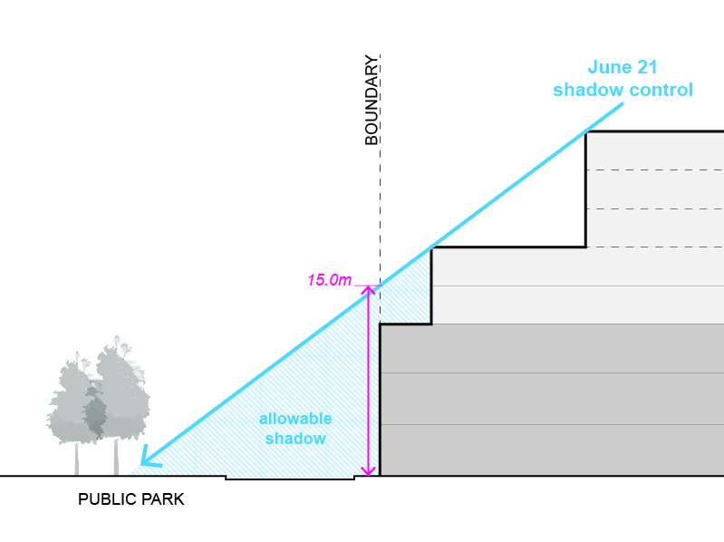

- Development must not cast a shadow beyond the southern kerb-line of North Drive and South Drive as identified in the East Village Comprehensive Development Plan, December 2018 between 10am and 3pm on 22 September.
- Development must not cast a shadow over any part of Virginia Park and the Marlborough Street Reserve as identified in the East Village Comprehensive Development Plan, December 2018 for at least 5 hours on 22 September.
- Development must not cast any shadow on more than 25% of the area of any public open space described in Plan 2 of the East Village Comprehensive Development Plan, December 2018 between 11am and 2pm on 21 June.
- Development should not cast any unreasonable shadows over other public parks and gardens, pedestrian routes including streets and lanes and privately owned but publically accessible spaces.
Drainage Strategy – South of Griffith Avenue
A permit must not be granted to construct a building or construct or carry out works on land south of Griffith Avenue until a drainage strategy for all land within the precinct to the south of Griffith Avenue, has been prepared to the satisfaction of the responsible authority and Melbourne Water.
A drainage strategy must be designed to ensure that development of the precinct can meet the following requirements:
- No new lots created that are subject to inundation from 1% AEP flows (accounting for climate change scenarios).
- Any overland paths in road reserves meet Melbourne Water’s floodway safety criteria for depth of flow and flow velocity.
- Any overland flows be fully contained within reserves (roads, open space).
- Flooding cannot be increased either upstream or downstream of the precinct or for existing landholders.
- The drainage network must have capacity for the 5% AEP flood.
A drainage strategy may be amended to the satisfaction of the responsible authority and Melbourne Water.
A permit to construct a building or construct or carry out works must be generally in accordance with any drainage strategy approved under this schedule.
A permit may be granted to construct a building or construct or carry out works prior to the approval of a drainage strategy if, in the opinion of the responsible authority, the permit is consistent with the requirements listed in this clause.
Provision of affordable housing
A permit must not be granted for residential development until the owner of the land enters into an agreement under section 173 of the Act that obligates the owner of the land to provide for either of the following:
  - Transfer of land within the East Village Comprehensive Development Plan, December 2018 and with a planning permit/s for a minimum of one-hundred and fifty (150) dwellings, at nil consideration to a housing association or associations registered under the Housing Act 1983. Seventy five (75) dwellings are to be transferred prior to the development of one thousand five hundred (1500) dwellings within the East Village precinct boundary and a further seventy five (75) dwellings are to be transferred prior to the development of two thousand one hundred (2100) dwellings within the East Village precinct boundary; or
  - The provision of affordable housing by any agreed alternative method consistent with the value of the above provision.
  - Where an alternative method is agreed, and the land owner has met all of its obligations under that method, that any obligation of the land owner to provide for affordable housing has been fully discharged.
Works to be provided in association with development
Development must provide and meet the total cost of delivering the following infrastructure, unless provided for in an incorporated development contributions plan:
- Connector streets and local streets;
- Local bus stop infrastructure where locations are agreed in writing by Public Transport Victoria;
- Landscaping, and where required by the Glen Eira City Council, fencing of abutting streets and roads;
- Intersection works and traffic management measures along arterial roads, connector streets and local streets;
- Local shared, pedestrian and bicycle paths along local roads, connector streets, utilities easements, local streets, waterways and within local parks including intersections and barrier crossing points;
- Bicycle parking;
- Appropriately scaled lighting along all roads, major shared and pedestrian paths and traversing the open space network;
- Local drainage system and water quality systems.

Application requirements
The following application requirements apply to an application for buildings and works in addition to those specified in Clause 37.02 and elsewhere in the scheme and must accompany an application, as appropriate, to the satisfaction of the responsible authority:
An application to construct a building or construct or carry out works must be accompanied by the following information, as appropriate:
- A written statement that sets out how the development implements the East Village Comprehensive Development Plan, December 2018.
- A plan showing the proposed development in the context of Plan 1 and the relevant plans in the East Village Comprehensive Development Plan, December 2018.
- A land budget table in the same format and methodology as those within the East Village Comprehensive Development Plan, December 2018 applying to the land, setting out the amount of land allocated to the proposed uses and expected population, dwelling and employment yields.
- A demonstration of how the development will contribute to the provision of 3,000 dwellings within the precinct, including a plan showing the location and total number of existing dwellings within the precinct.
- A feature survey and site reestablishment plan.
- A staging plan showing staging of the development/road construction/service provision/land release to ensure that it would be developed in an orderly way.
- A site analysis plan showing:
- Existing conditions.
- The boundaries and dimensions of the site.
- The location of existing buildings to be retained/demolished.
- Relevant ground levels to AHD.
- The location, height and purpose of buildings and works on adjoining land.
- The location and height of all existing buildings on the land.
- The location of existing services, easements and encumbrances on the land.
- The location of existing driveways, car parking and loading areas, including the allocation of existing parking spaces on the site.
- The location of private open space of adjoining properties.
- A design response plan drawn to scale which shows:
- The boundaries and dimensions of the site.
- Adjoining roads.
- Relevant ground levels to AHD.
- The layout of proposed buildings and works.
- Proposed driveway, car parking and loading areas.
- Proposed landscape areas.
- Proposed external storage and waste treatment areas.
- Areas not required for immediate use.
- Number of car parking spaces per dwelling and visitor car parking.
- Bicycle parking provision.
- Details of connections from any internal roads/accessways to existing roads and means of vehicular ingress and egress from the site.
- Elevation drawings to scale showing the colour and materials of all buildings and works.
- Details of measures to mitigate noise, odour, vibration and other amenity impacts.
- Shadow diagrams at hourly intervals from 9am to 3pm at September equinox and from 11am to 2pm at winter solstice.
- Schedule of construction materials, external finishes and colours.
- Plans showing the design of streets, paths, parks and any other relevant public facility or infrastructure shown in the East Village Comprehensive Development Plan, December 2018, shown in a development contributions plan, or that is necessary as a result of the development.
- A plan showing the proposed development in the context of Plan 1 and any other relevant plan in the East Village Comprehensive Development Plan, December 2018.
- 3D images that depict the proposed development (taken from pedestrian eye-level) in the context of the adjacent (existing and approved/proposed) buildings. The photomontages / 3D images must be produced in colour and accurately depict the proposed palette of building materials and finishes
- For applications within the mixed use and retail sub-precincts, and commercial sub-precincts, 1:20 scale elevation drawings of the primary, ground floor (street) level façade, accompanied by a detailed materials schedule and written statement explaining how the design of the ground floor façade encourages pedestrian activity and informal surveillance of the street from within the building.
- Construction details of all drainage works, driveways, vehicle parking and loading areas.
- An arboricultural report.
- A landscape layout which includes the description of vegetation to be planted, the surfaces to be constructed, site works specification and method of preparing, draining, watering and maintaining the landscape area.
- A waste management plan which includes the following, as appropriate:
- The location of waste storage facilities on site and on collection days, including bulk waste collection bins or approved alternative and recycling bins
- The proposed method of waste collection (either private contractor or Glen Eira City Council). If private collection is proposed, it must incorporate recycling services and comply with the relevant EPA noise guideline relating to time of collection.
- A traffic, parking and access report which includes the following:
- An assessment of the total vehicle movements to and from the entire precinct during peak periods. This is to include an assessment of the precinct’s existing and the proposed development traffic generation during peak AM and PM period.
- An assessment of the likely traffic impacts associated with the proposed development, including the ability of the Cobar Street / North Road / Crosbie Road intersection to function effectively without signalisation (if not already signalised), and the implications on the operation of the broader network, including the capacity of the North Road / East Boundary Road / Murrumbeena Road intersection.
- Traffic management works which may be necessary to accommodate the predicted traffic generated by the development.
- An assessment of the proposed car parking provision including suitability of scale, location and capacity to service the anticipated car parking demand.
- A site remediation strategy prepared by a suitably qualified professional that:
- Demonstrates the proposed staging of development to accommodate any required remediation works and how any contamination is being managed to prevent any detrimental effect on the use and development of the subject land or adjoining land or on buildings and works; and
- Where applicable, provides recommendations regarding the suitability of the site for installation of underground water storage tanks.
- A construction management plan which includes an assessment of the impacts of noise and vibration from the proposed development. The plan should demonstrate that existing residents in the vicinity of the development will experience a reasonable level of amenity during the construction phase.
- A Public Infrastructure Plan which addresses the following:
- What land may be affected or required for the provision of infrastructure works;
- The provision, staging and timing of road works internal and external to the land consistent with any relevant traffic report or assessment;
- What, if any, infrastructure set out in the development contributions plan applying to the land is sought to be provided as "works in lieu" subject to the consent of the collecting agency;
- The provision of public open space and land for any community facilities; and
- Any other matter relevant to the provision of public infrastructure required by the responsible authority.
Neighbourhood and site description and design response
An application for any of the following must be accompanied by a neighbourhood and site description and a design response as described in Clause 54.01 or 55.01, as appropriate:
- Construction or extension of one dwelling on a lot of less than 300 square metres.
- Construction of a dwelling if there is at least one dwelling existing on the lot.
- Construction of two or more dwellings on a lot.
- Extension of a dwelling if there are two or more dwellings on the lot.
- Construction or extension of a dwelling on common property.
- Construction or extension of a residential building.
Environmental site assessment – Commercial North
An application to construct a building or construct or carry out works on land in the Commercial North sub-precinct or Commercial North (subject to drainage controls) shown on Plan 1 of this schedule must be accompanied by an Environmental Site Assessment (Detailed Site Investigation) prepared by a suitably qualified practitioner in contaminated land assessment which takes account of the report titled East Village Peer Review and Phase 1 Environmental Site Assessment (Bluesphere Environmental, 25 July 2018) and provides information including:
- Further detailed assessment of potential contaminants on the relevant land;
- Clear advice on whether the environmental condition of the land is suitable for the proposed use;
- Recommended remediation actions for any potentially contaminated land.
The Environmental Site Assessment (Detailed Site Investigation) must be completed in accordance with the National Environment Protection (Assessment of Site Contamination) Measure (2013) and relevant Environment Protection Authority (EPA) legislation and guidance.
Amenity assessment – buildings associated with a sensitive use
An application to construct a building associated with a sensitive use must be accompanied by an amenity assessment report that includes the following:
- acoustic assessment prepared by a suitably qualified professional. The assessment should provide recommendations on suitable design responses to ensure future occupants will experience an appropriate level of acoustic amenity within the proposed building;
- an assessment of other potential amenity impacts from nearby non-sensitive uses including fumes, odour, light spillage prepared by a suitably qualified professional. The assessment should provide recommendations on suitable design responses to ensure future occupants will experience an appropriate level of amenity within the proposed building
Acoustic assessment for development with a direct interface to electrical substation
An application to construct a building on land with a direct interface to the electrical substation shown on Plan 1 of this schedule must be accompanied by an acoustic report prepared by a suitably qualified professional. The report should provide recommendations on suitable design responses that ensure future occupants will experience an appropriate level of acoustic amenity within the proposed building.
Sustainability management plan
An application to construct an office or apartment building must be accompanied by a sustainability management plan prepared by a suitably qualified professional or other suitably skilled person that demonstrates to the satisfaction of the responsible authority:
- The adoption of best practice environmental management during construction including:
- Provision for the minimisation, re-use and recycling of materials and waste.
- The inclusion of energy efficient street lighting that makes optimum use of smart technology to minimise energy use.
- That the building will be designed to provide the opportunity for reduced energy and resource use by occupants including:
- Maximise access to natural ventilation of interior spaces
- Maximise direct daylight access and views to outdoor spaces
- Minimise hard surfaces and maximise vegetated areas in spaces ancillary to the building
- Passive design features to reduce heat gain in summer and maximise heat gain in winter
- Energy efficient building services
- Providing for on-site energy production
- Maximise opportunities for water capture and re-use.
- Use of the Green Star Design or UDIA’s EnviroDevelop tool (or alternative tool as agreed by the responsible authority) for design and construction of all buildings.
Decision guidelines
The following decision gudelines apply to an application for a permit under Clause 37.02, in addition to those specified in Clause 37.02 and elsewhere in the scheme which must be considered, as appropriate, by the responsible authority:
- The East Village Comprehensive Development Plan, December 2018.
- The extent that the layout and design of the new development minimises the potential for off-site impacts, including from noise, fumes, odour or vibrations, ensuring that:
- existing uses are not compromised by a new development, or
- a new development is designed to address amenity impacts from, and to, existing uses.
- For a building associated with a residential use, whether the building is designed to effectively mitigate noise, fumes, odour, vibration and other associated amenity impacts from non-residential uses.
- The movement of pedestrians and cyclists, and vehicles providing for supplies, waste removal, emergency services and public transport.
- The effect of traffic to be generated by the development on the capacity of the local and regional traffic network, including the operation of the East Boundary Road / North Road intersection.
- Where it is demonstrated that the traffic volume generated by the precinct is approaching or exceeds 2,000 vehicles at the peak hour, the ability of the Cobar Street / North Road / Crosbie Street intersection to function effectively without signalisation and the implications on the operation of the broader network, including the capacity of the North Road / East Boundary Road / Murumbeena Road intersection.
- The provision of car parking.
- How the design of ground level building facades contribute to a fine-grain built form and a pedestrian friendly, visually interesting streetscape.
- The streetscape, including the design of verandahs, access from the street front, protecting active frontages to pedestrian areas, the treatment of the fronts and backs of buildings and their appurtenances, illumination of buildings or their immediate spaces and the landscaping of land adjoining a road.
- The location of storage for rubbish and materials for recycling.
- Whether there are clearly defined responsibilities and arrangements proposed for the maintenance of buildings, landscaping and paved areas.
- The overlooking and overshadowing as a result of building or works affecting adjoining land in the Neighbourhood Residential Zone.
- The availability of and connection to services.
- The design of buildings to provide for solar access.
- The objectives, standards and decision guidelines of Clause 54 and Clause 55.
5.0 Signs
--/--/20--Proposed C155

Sign requirements are at Clause 52.05. All land located within a residential sub-precinct as shown in Plan 1 is in Category 3. All land located within a commercial sub-precinct, retail sub-precinct or mixed use sub-precinct as shown in Plan 1 is in Category 1. All other land is in Category 4.

