Planning and Environment Act 1987

GLEN EIRA PLANNING SCHEME

Notice of the Preparation of an Amendment to a Planning Scheme
Amendment C155

The land affected by the Amendment is the land described within the East Village Comprehensive Development Plan, December 2018 (the CDP), shown in Map 1 below and known as East Village. The CDP affects approximately 25 hectares of predominately industrial/commercial land, bounded by North Road (north), East Boundary Road (west), Virginia Park (south) and existing residential development (east), in Bentleigh East. Seven residential-zoned properties are included within the CDP.

Map 1 Amendment area

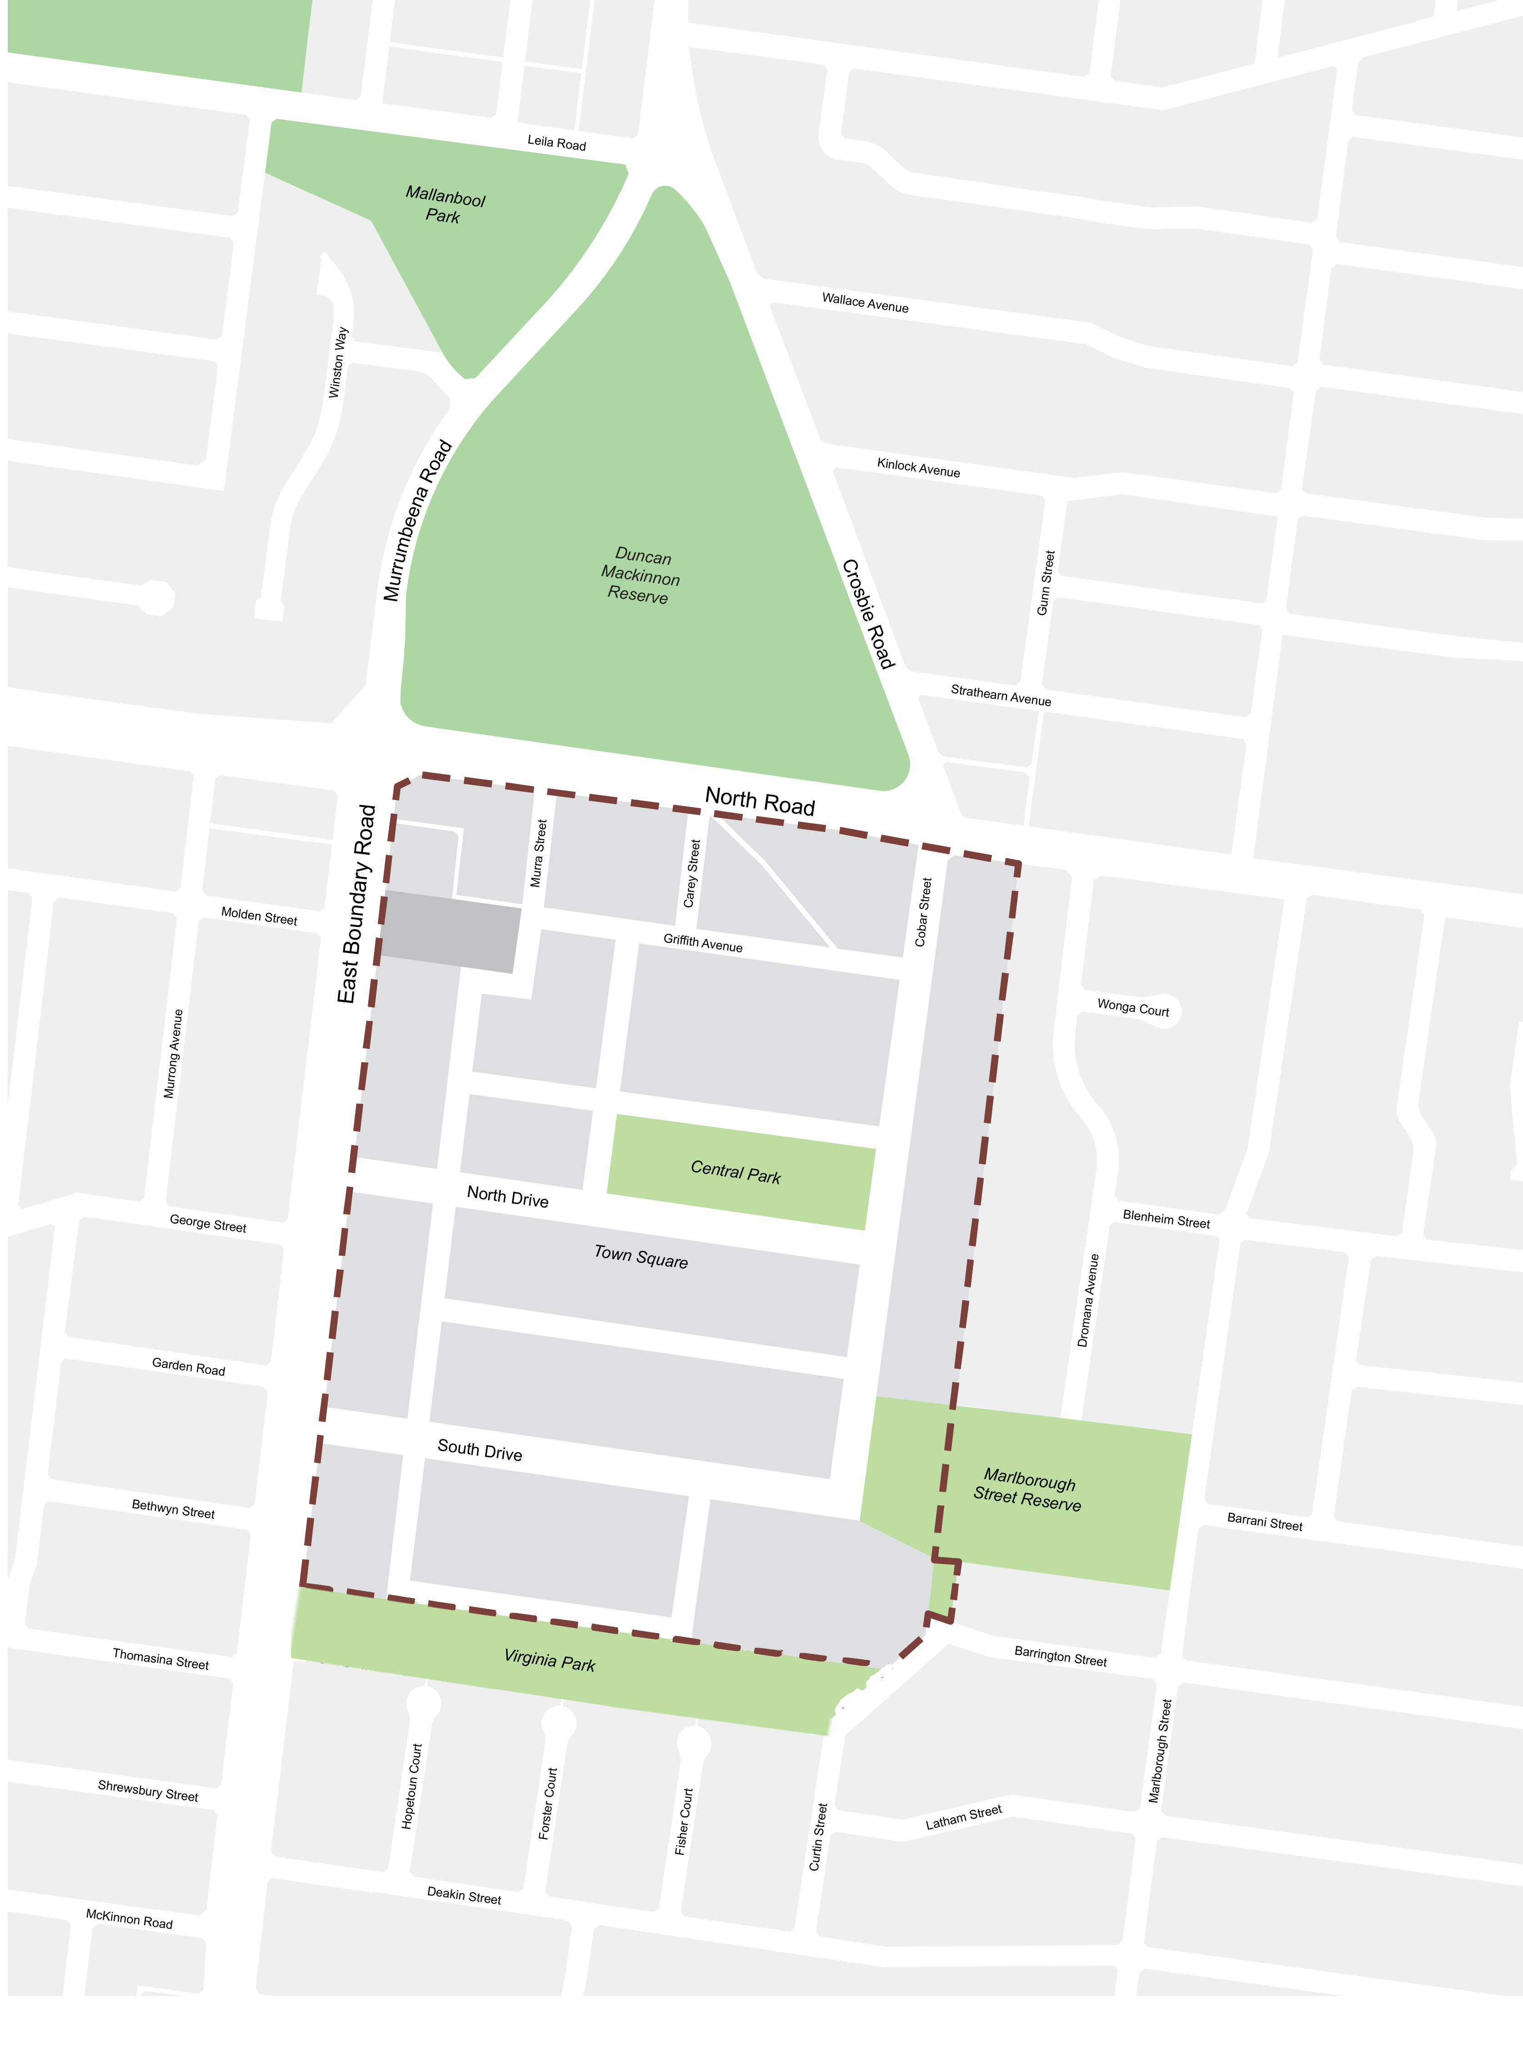

The Amendment proposes to;

Amend the Municipal Strategic Statement (MSS) at Clause 21.01 and Clause 21.03 to remove reference to Virginia Park Industrial Estate and Virginia Park Business Centre as forming the base of industry in Glen Eira and being the municipality’s largest industrial area.

Amend the Local Planning Policy Framework at Clause 21.06 – Business and 21.07 – Industry to remove reference to Virginia Park Industrial Estate and Virginia Park Business Centre, removes reference to rezoning land to Commercial 1 Zone, Business 2 Zone, Business 3 Zone and Industrial 1 Zone, and inserts reference to East Village.

Incorporate two new documents into the Planning Scheme by listing the documents in the Schedule to Clause 72.04 as:

East Village Comprehensive Development Plan, December 2018

East Village Development Contributions Plan, October 2018

Insert Schedule 2 to Clause 37.02 Comprehensive Development Zone (CDZ2) into the Scheme.

Insert Map 4CDZ and rezones the land to CDZ2.

Insert Clause 45.06 – Development Contributions Plan Overlay (DCPO) into the Scheme.

Insert Schedule 1 to Clause 45.06 into the Scheme.

Insert Map 4DCPO and applies the Development Contributions Plan Overlay –Schedule 1 (DCPO1) to the land within the CDP area.

Amend Map 4EAO to apply the Environmental Audit Overlay (EAO) to land within the CDP area previously zoned Industrial 1 Zone (IN1Z).

Delete Map 4DPO (Development Plan Overlay) from the planning scheme maps.

Update the schedule to Clause 53.01 to require subdivision within the Commercial North sub precinct, Commercial west sub precinct and Commercial north (subject to drainage control) sub precinct to provide a contribution towards open space of 5.7%. All other land within the precinct will be required to provide a contribution of 11.4%.

Update the schedule to Clause 72.03 to reflect mapping changes.

Update the Schedule to Clause 72.08 Background Documents - to include East Village Structure Plan 2018-2031 as a background document to Amendment C155.

You may inspect the Amendment, the Explanatory Report about the Amendment, and any documents that support the Amendment, free of charge, at the following locations:

- during office hours, at the office of the planning authority, corner of Hawthorn Road, and Glen Eira Road, Caulfield;
- at Council’s website www.gleneira.vic.gov.au/east-village;
- At VPA’s website www.vpa.vic.gov.au; or
- at the Department of Environment, Land, Water and Planning website www.delwp.vic.gov.au/public-inspection

Any person who may be affected by the Amendment may make a submission to the planning authority about the amendment. Submissions must be made in writing giving the submitter’s name and contact address, clearly stating the grounds on which the Amendment is supported or opposed and indicating what changes (if any) the submitter wishes to make.

Name and contact details of submitters are required for Council to consider submissions and to notify such persons of the opportunity to attend Council meetings and any public hearing held to consider submissions.

The closing date for submissions is 9 October 2019. A submission must be lodged online or sent to Glen Eira Council, Po Box 42, Caulfield 3162.

The planning authority must make a copy of every submission available at its office for any person to inspect free of charge until the end of the two months after the amendment comes into operation or lapses.

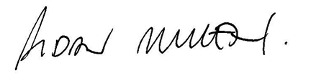

AIDAN MULLEN
MANAGER CITY FUTURES

