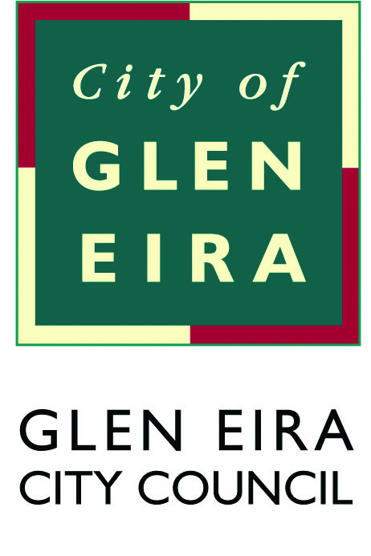
Disability Action Plan
2017–2021

Summary version

Purpose
The Glen Eira Disability Action Plan 2017–2021 (the Plan) will guide Council’s efforts to support people with disabilities to fully participate in all aspects of community life in Glen Eira.
The Plan adopts a whole-of-Council approach focused on building a community that is accessible and inclusive to people of all-abilities.
Council’s vision is for Glen Eira to be an active and involved community with a strong sense of belonging and connection, where all people can feel welcomed, supported and valued.

What our community told us
This Plan was developed through widespread consultation with the community, including people with disabilities; parents, family members and carers of people with disabilities; Council staff; and local disability service providers.
The most prominent themes identified:
- More opportunities for social connection, involvement and inclusion.
- Accessible buildings, shops, facilities, amenities and transport.
- The need to change community attitudes through awareness raising.
- Training/education and making people with disabilities more visible in the community.
- More opportunities for employment, volunteering and ongoing education.
- Accessible information about services, events and activities available in a range of formats.
- More designated accessible parking and better monitoring of designated accessible parking.
- Stronger Council leadership in promoting the value of people with disabilities.

Priorities
Under the Disability Act 2006, Council is required to develop a Disability Action Plan to demonstrate how we will reduce barriers in areas such as employment, services and facilities, as well as promote participation and inclusive attitudes.
The Plan identifies four key priorities areas which incorporate a range of strategies and activities Council will undertake over the next four years.
The four themes of the Disability Action Plan 2017–2021 are:

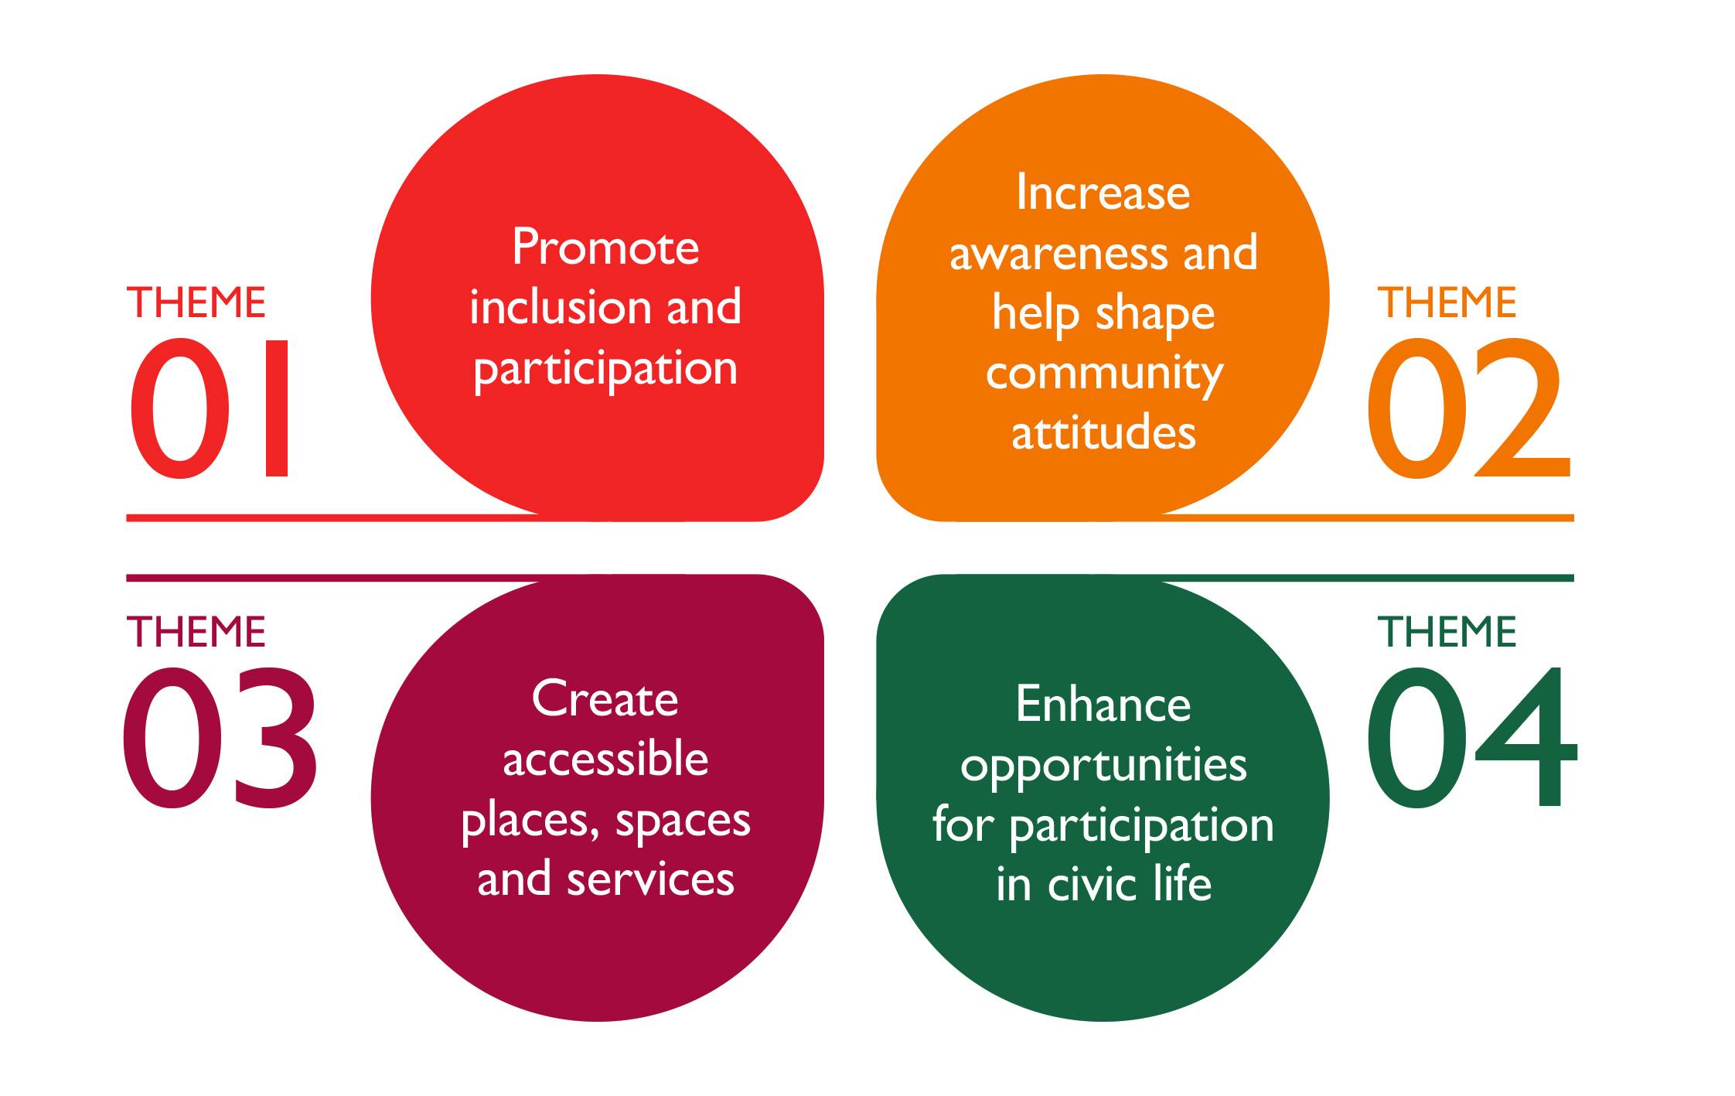

Theme one
Promote inclusion and participation
Council provides a comprehensive range of quality, accessible and community building programs and services to meet the needs of people with a disability in Glen Eira.
Local opportunities and choices for social connection, involvement and inclusion are essential for people with disabilities to actively participate in community life.
Key actions include:
- Promote inclusion and raise awareness of issues of discrimination experienced by people with disabilities. This includes people with disabilities who identify as Aboriginal, Torres Strait Islander people, culturally and linguistically diverse communities and LGBTI (Lesbian, Gay, Bisexual, Transgender and Intersex).
- Ensure that Council events are accessible to all members of the community.
- Ensure that key Council information and publications are accessible and available in a range of formats.
- Identify opportunities for partnerships with local networks, service providers and community groups around activities for social connection and inclusion.
- Develop strategies to ensure information about local support services, activities and events reaches people with disabilities in Glen Eira.

Theme two
Increase awareness and help shape community attitudes
People with a disability want to be accepted and included in a respectful and welcoming community which celebrates diversity. Awareness raising and education initiatives increase staff and community awareness around inclusive practices and promote acceptance within the community.
Key actions include:
- Provide training and education for Council staff and volunteers and raise awareness of the barriers people with disabilities may face and strategies to support them.
- Provide training and education for the community around accessibility, communication and general disability awareness.
- Engage local businesses to be more aware of access and inclusion.
- Recognise and promote the abilities of people with disabilities and the contribution they make to the community.

Theme three
Create accessible places, spaces and services
Well maintained infrastructure such as roads, footpaths and parklands make it easier and safer for people with disabilities to move about the community. People need to be able to get to and move around in buildings, places and spaces in order to be able to study, work, enjoy leisure, use shops and services, and visit family and friends.
Key actions include:
- Improve the accessibility of Council buildings and facilities.
- Ensure access is embedded in all Council planning and building initiatives.
- Provide and promote equitable access to Council services and programs, which are responsive to the needs of people with disabilities, their families and carers.
- Provide opportunities for people with disabilities to contribute to Council’s planning processes and to raise issues.
- Improve accessible parking options around shops and services for people with disabilities in Glen Eira.

Theme four
Enhance opportunities for participation in civic life
By leading by example and providing community awareness, Council can help to change community attitudes and ensure Glen Eira is a welcoming and inclusive community for all.
Many people with disabilities would like to work but face barriers securing employment.
Employment as well as volunteering, provides an opportunity to make friends, develop networks, build confidence, acquire new skills and contribute to society.
Key actions include:
- Be a role model employer, introducing strategies to increase the representation of people with disabilities across Council’s workforce.
- Support and encourage local opportunities in employment and economic participation for people with disabilities in Glen Eira.
- Enhance volunteering opportunities for people with disabilities within Council.
- Advocate for the needs of people with disabilities to reduce barriers to participation such as housing and infrastructure development.
- Facilitate and participate in networks which strengthen Council’s ability to identify and respond to issues.

A full version of the Disability Action Plan 2017–2021 can be found on Council’s website: www.gleneira.vic.gov.au/dap

