Statement of Significance: Former ABC TV Gordon Street Studios

Address: | 8 Gordon Street, Elsternwick | Name: | Former ABC TV Gordon Street Studios
Place Type: | Government/Institutional | Grading: | Significant
PS ref no: | HO156 | Constructed: | 1956-1965

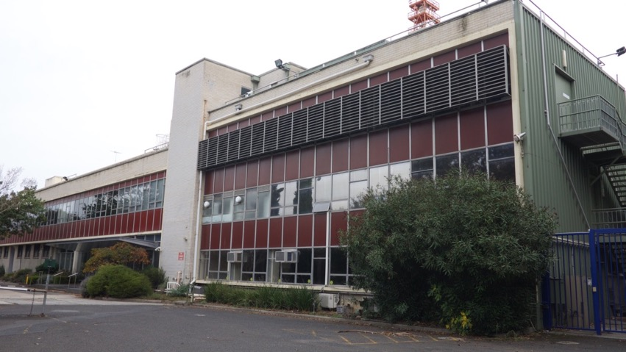
Exterior of Gordon Street Studios from car park. Photo by heritage ALLIANCE, 2018

What is significant?

The ABC TV Gordon Street studios are of cultural significance at the National, State and Local level as a place associated with public broadcasting by the Australian Broadcasting Corporation since 1956. It is a rare, surviving twentieth century television studio and the earliest ABC television studio left in Australia. The site and its fabric reflects technological developments in television from the nascent technology of 16mm film production to telecine, videotape, colour broadcasting and then digital broadcasting, from 1956 until 2017. The studios are associated with a medium which had far-reaching effects on Australian culture, ideas, identity and society from 1956 until 2017.

The following elements on the site are significant:
- The transmission tower;
- Stage 1, 2 and 3 buildings, particularly the facades facing the former car park, the facades facing the former engineering workshop and the façade facing 2 Gordon Street.
- Internal areas of significance include former Television Studios 31, 32, 33A and 33B (1958). The important elements of the studios include the soundproofing, lighting and some electrical elements and the relationship between the studio floor and the master control room above; the Scenery Runway, and the service areas surrounding the studio which house the former makeup, wardrobe, dressing rooms, toilets, green room and technical crew spaces with an intervening corridor.

Diagram A0-1 indicates the location of the Transmission Tower and the significant and contributory facades and internal areas.

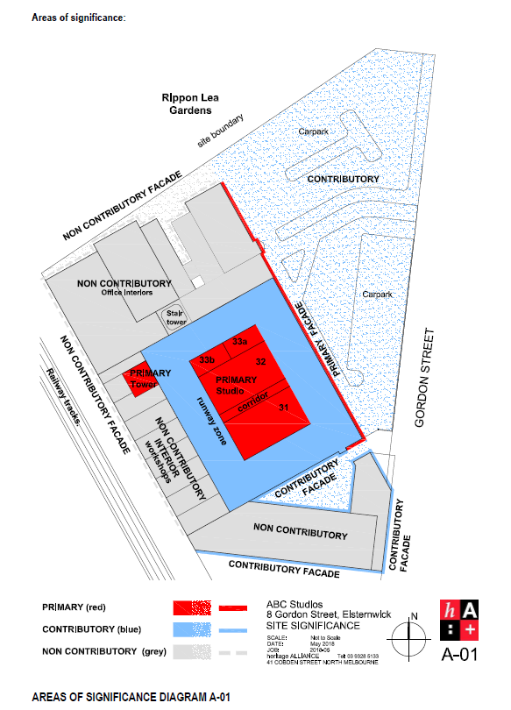

How is it significant?
The ABC TV studios located at 8 Gordon Street, Elsternwick are significant at National, State and Local levels for historical, architectural, cultural, social and technological reasons.
Why is it significant?
Criterion A: Importance to the course or pattern of our cultural or natural history (historical significance).
- Association with the beginnings of television in Australia, with public broadcasting by the ABC since 1956 and the earliest ABC television studios still extant in Australia. (Commonwealth)
- Association with a medium which had far-reaching effects on Australian culture, ideas, identity and society in the late twentieth century. (National)
- The site of the first public television broadcast in Victoria. (State)
- Association with the first Olympic Games held in Australia (Melbourne 1956). (State)
- Association with the development of a heritage conservation and advocacy movement and the nascent National Trust in Victoria. (Local)
- Association with Rippon Lea Estate and the Jones family. (Local)
Criterion B: Possession of uncommon rare or endangered aspects of our cultural or natural history (rarity).
- Earliest extant ABC television studio in Australia. (National)
- Rare, surviving twentieth century television studio in Australia. (National)
- One of only a few government/institutional buildings in City of Glen Eira with an aesthetic presence. (Local)
- Rare Post-War International style building in City of Glen Eira. (Local)
Criterion E: Importance in exhibiting particular aesthetic characteristics (aesthetic significance).
- The design of the building demonstrates influence by the International style, which was in vogue between 1940 and 1960 and was popular in the Commonwealth Public Works Department at the time of its construction. It is one of the few buildings in the City of Glen Eira in this style and at a substantially large scale. (Local)
Criterion F: Importance in demonstrating a high degree of creative or technical achievement at a particular period (technical significance).
- Demonstrates the development of technological design and innovation in the nascent television industry of the 1950s and the influence of overseas experts on Australian technicians, designers and engineers. (National)
- Demonstrates changing technology in television production and broadcasting from film to video to digital broadcasting, between 1956 until 2017. (National)
Criterion G: Strong or special association with a particular community or cultural group for social, cultural or spiritual reasons. This includes the significance of a place to Indigenous peoples as part of their continuing and developing cultural traditions (social significance).
- Special association with generations of Australians who were influenced by ABC Television programmes and in particular the series Bellbird, Countdown, and Sea Change, current affairs and news programmes and the enormous cultural influence these programmes have had on Australian society. (State)
- Special association with staff of the ABC who worked in the building. (Local)
Criterion H: Special association with the life or works of a person, or group of persons, of importance in our history (associative significance).
- Special association with the development of a nascent entertainment and broadcasting industry, which went on to develop Australian talent in music, film, video, journalism, acting, direction, design and production and has directly contributed to the development and dissemination of a distinctive Australian culture. (National and State)
Primary source
Heritage Citation – Former ABC TV Studios, Elsternwick, 1 November 2018,
prepared by heritage ALLIANCE

Heritage Assessment – ABC TV Studios, 8 Gordon Street, June 2018

