HERITAGE CITATION City of Glen Eira

Heritage Overlay number: HO156

Place Name: Former ABC TV Gordon Street Studios

Other Names: ABC TV Ripponlea Studios

Address: 8 Gordon Street, Elsternwick

Place Type: Government/Institutional
Designer/architect: Commonwealth Public Works Department
Construction dates: 1956-1965
Architectural style: International Style

Level of Significance: LOCAL, STATE, NATIONAL

Recommendation: Heritage Overlay schedule
Victorian Heritage Register
Commonwealth Heritage List

_______________________________________________________________________________________
Photos:

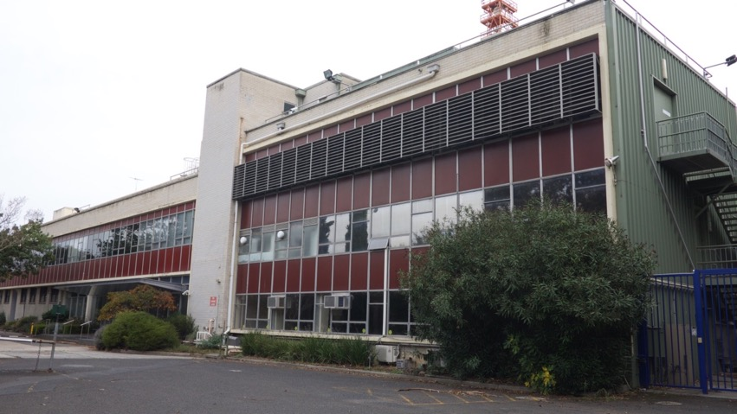
Exterior of Gordon Street studios from carpark. Photo by heritage ALLIANCE, 2018

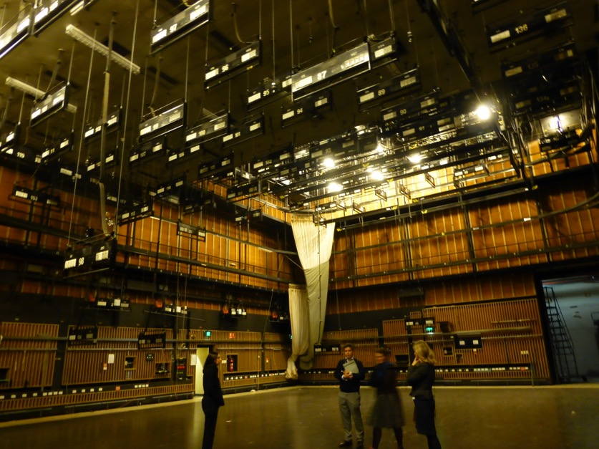
Studio 31 interior. Photo by heritage ALLIANCE, 2018

History:

The City of Glen Eira lies within Boon Wurrung country, people of the Kulin Nation, who are the traditional custodians of the Port Phillip and Westernport Bays and South East Victoria. The Boon Wurrung Foundation represents the traditions and beliefs of the Boon Wurrung and cares for their country, people and language.

The land that 8 Gordon Street, Elsternwick lies on was first sighted by Europeans at the turn of the nineteenth century with early surveys by Matthew Flinders in 1802 and then the first forays by Van Diemen's Land settlers in the 1830s. In September 1836, under pressure from the number of illegal occupations and squatting which had occurred, the Port Phillip land district was proclaimed open for settlement, allowing for the sale of Boon Wurrung lands, to be sold by the Crown to Europeans. This meant that access to traditional Boon Wurrung lands, resources and cultural sites was alienated without their consent.

8 Gordon Street, Elsternwick formed part of the property Rippon Lea which was purchased from the Crown by Frederick Sargood, who in 1850, at fifteen years of age, had arrived in Melbourne from England with his family. Sargood made a fortune, became a leader of Melbourne society, a notable political figure and Victoria’s first Minister of Defence, and after Federation was elected to Australia’s first Senate. He was knighted in 1890. Sargood acquired 27 hectares of Boon Wurrung land in Elsternwick and began to establish an English style estate.
From 1868 Sargood began to develop magnificent gardens around the house, both ornamental and practical, and by 1903 Rippon Lea had one of the largest private gardens in Australia. After Sargood’s death in 1903 the property was owned by Sir Thomas Bent, then Premier of Victoria, who subdivided and sold part of the property to the north. From 1911-35, the owner was Benjamin Nathan, the founder of Maples’ furniture stores, who added a gate lodge at the entrance and a large glasshouse for the propagation of orchids.

The property was inherited in 1935 by Nathan's daughter, Mrs Louisa Jones, who in 1939 altered the house, added a pool complex and also subdivided and sold some of the property. The Jones family had started to sell off parts of the estate in the mid 1950s. In circa 1954, the conservatories and glass houses were dismantled, the huge circular vegetable garden was subdivided for suburban housing, extending Gordon Street from Bent Street to Glen Eira Road. Then in April 1956, Charles Moses, manager of the ABC and Timothy Jones, husband of Louisa Jones, came to an agreement for the ABC to purchase 2.75 acres of the estate and also sought the first right of refusal to purchase additional land from the estate for a television studio.

Stage 1 of the ABC studios was constructed in 1956 in the triangle of paddocks between the Rippon Lea lake, the railway line and adjacent to the Elsternwick police station and court house. In 1958, Stage 2 of the facility opened on 21 May. In 1959, the ABC successfully negotiated to buy another two acres of Rippon Lea but the purchase was not completed because of objections by Caulfield City Council. Negotiations with Mrs Jones were later resumed but she rescinded the agreement to sell more land on the basis that the agreement was made by her late husband, not her.

In 1963, the government compulsorily acquired 4.1 acres of the estate to extend the ABC facility. 10,000 people protested the acquisition in the grounds of Rippon Lea. Louisa Jones took her battle all the way to the High Court, who denied the acquisition on a technical detail. In 1964 the ABC reapplied for the acquisition and again it went all the way to the High Court, who upheld the right of the Commonwealth to acquire the land. Louisa Jones still did not give up, and in 1966 she issued a writ against the Commonwealth for 355,000 pounds.

Having lost two court cases, she then bequeathed the property to the fledgling National Trust of Australia (Vic) to successfully preserve the property for the people of Victoria. She received this news shortly before she died in 1972, aged seventy-eight. As Henry Bolte, Victorian Premier of the time remarked, ‘Few people have worked so hard to give so much away.’

Television began in Australia just in time for the Melbourne Olympics of 1956. A 1953 Federal Royal Commission Inquiry into Television, had recommended that it be introduced gradually under government supervision, with an ABC station and two commercial channels in both Sydney and Melbourne. Throughout 1956, international experts were flown into Melbourne to prepare staff, train 300 technicians and provide expertise on how to design studios and production facilities for television.
Test transmissions took place in Melbourne for HSV7 and GTV9 in the months leading up to the Olympic Games and, along with ABV2, the stations were on air by the time the Olympics began in November. All three stations televised the Olympics, using outside broadcast vans linked by radio to their main studios and a 16mm film of daily events sent to Sydney each evening for television broadcast.
The first transmission of Channel ABV2 in Melbourne was on November 17, 1956. The opening programmes were presented from a converted radio studio at Broadcast House, using the Outside Broadcast unit as a production booth. Programmes were presented from the small studio at Gordon Street with the master control equipment being housed in the Garage building of Stage 1.
It was May 1958 before ABV2 formally opened the studio space at Gordon Street. An undated memo from ABV2 staff collected on an ABV2 archive website provides some details about the building. “The requirements for the studio building were prepared by officers of the Australian Broadcasting Commission based on the latest experience of television authorities overseas. The plans were prepared and the building construction supervised by the Commonwealth Department of Works. The building contractors are Clements Langford Pty Ltd.”
The Gordon Street studios continued to house ABC TV production in Melbourne until 2017 — making programs such as Bellbird, Adventure Island, Countdown, Power Without Glory, The Saturday Show, Australia – You’re Standing In It, The Factory, Countdown Revolution, The Big Gig, The Late Show, Phoenix, Seachange, Shaun Micallef’s Mad As Hell, Spicks And Specks, schools programs and thousands of ABC News and current affairs programs.
In June 2011, the Managing Director of the ABC, Mark Scott announced that they would build a new TV studio at Southbank. “Recently unions have raised concerns about the ongoing production output by the public broadcaster. But while Scott says Melbourne will remain a major hub for ABC television it isn’t clear what, if any, role will be played by the Elsternwick studios. ‘The Gordon Street facilities date back to the origins of television in Australia and have been home to many of the ABC’s most memorable productions, from Countdown and Seachange to Spicks and Specks and Adam Hills in Gordon Street, whose live show made the location famous.’
The ABC TV Gordon Street studios were closed in November 2017.
Social significance:
The ABC TV studios at Gordon Street have had a lasting impact on the entertainment industry in Australia, as a workplace for actors, directors, producers, editors, cameramen and other trades, from 1956 until 2017. The first generation of television technicians and creators was trained in the Gordon Street facility and then passed that knowledge onto the next generations of television actors, producers and technicians. There is a general feeling of sentimental attachment to the building known to most everyone who worked there simply as Ripponlea.

The sporadic and cyclical nature of television production has meant that many people would have worked on productions for one or two episodes or might have worked on long series on a regular basis, over many decades. Over 300 staff were permanently employed at the site at different times, in roles from creative production, technical trades and administration. Their attachment to the facility and the workplace culture of the place has created a lasting attachment evidenced in video interviews conducted by the ABC with actors, directors and staff.
Andrew Best, set buyer/dresser and unofficial historian of Ripponlea studios worked at the Gordon Street studios for 36 years and occasionally conducted public tours of the site. Andrew says that; “In the 1960s this was called the ‘dream factory’ because it was the beginning of TV and really anything you could dream up was new and exciting and you could create it here.” “It does really have that feeling that just anything could happen here and so many wonderful shows have come out of here.”

Not only permanent ABC staff but also actors, directors and producers have attachment to the buildings and the programs produced within them. Actors such as Deborra-Lee Furness who worked at the Gordon Street studios felt there was something magical about the culture of the place that gave rise to such great program content. "There's a bit of magic in Ripponlea. It allowed people … to be more creative, to have more artistic leeway."

Charlie Pickering, host of The Weekly, felt lucky to be "that little bookend on history", filming one of the last programs in the famed Studio 31. "It's hard not to feel sentimental about it. This place was built as a factory of entertainment," he said. "Walking into this studio made you feel like you were stepping into history. You can see, almost feel, the history on the walls." Belinda Hawkins started at the ABC in 1985. She believes that having everyone together in one building — including news, the drama department, technical crews, set designers, the natural history department and the costume department — created a unique environment.

The ABC produced television programs from the Gordon Street studios, which have had a lasting effect on a broad sector of Australian society and culture. The list of programs produced in the studios crosses generations and communities and some, such as Countdown, had a lasting impact on the culture, music and taste of a whole generation and an enormous cohort of music, video, fashion and design practitioners in the 1970s and 80s. Other series such as Bellbird (1967-1977) and Sea Change (1998-2000) had a lasting impact on a generation of Australians and are remembered as marking a particular time in Australian family life and home-based entertainment. Seachange is noted in the Australian National Dictionary as a noun directly related to the ABC TV series, Sea Change and follows up with seachange (verb) as a move from city to coastal living. Sea Change was and is still the only program produced by the ABC to win a Gold Logie for Most Popular Australian Program. (2000 and 2001) The ABC produced and created numerous telemovies, current affairs and natural history programs at Gordon Street, and two Logie Awards for Most Popular Entertainment Program attests to the popularity of Kath and Kim and Spicks and Specks, produced and created at Gordon Street.

Statement of Significance:

What is significant?

The ABC TV Gordon Street studios are of cultural significance at the National, State and Local level as a place associated with public broadcasting by the Australian Broadcasting Corporation since 1956. It is a rare, surviving twentieth century television studio and the earliest ABC television studio left in Australia. The site and its fabric reflects technological developments in television from the nascent technology of 16mm film production to telecine, videotape, colour broadcasting and then digital broadcasting, from 1956 until 2017. The studios are associated with a medium which had far-reaching effects on Australian culture, ideas, identity and society from 1956 until 2017.

The following elements on the site are significant:
- The transmission tower;
- Stage 1, 2 and 3 buildings, particularly the facades facing the former car park, the facades facing the former engineering workshop and the façade facing 2 Gordon Street.
- Internal areas of significance include former Television Studios 31, 32, 33A and 33B (1958). The important elements of the studios include the soundproofing, lighting and some electrical elements and the relationship between the studio floor and the master control room above; the Scenery Runway, and the service areas surrounding the studio which house the former makeup, wardrobe, dressing rooms, toilets, green room and technical crew spaces with an intervening corridor.

How is it significant?
The ABC TV studios located at 8 Gordon Street, Elsternwick are significant at National, State and Local levels for historical, architectural, cultural, social and technological reasons.

Why is it significant?
Criterion A: Importance to the course or pattern of our cultural or natural history (historical significance).
- Association with the beginnings of television in Australia, with public broadcasting by the ABC since 1956 and the earliest ABC television studios still extant in Australia. (Commonwealth)
- Association with a medium which had far-reaching effects on Australian culture, ideas, identity and society in the late twentieth century. (National)
- The site of the first public television broadcast in Victoria. (State)
- Association with the first Olympic Games held in Australia (Melbourne 1956). (State)
- Association with the development of a heritage conservation and advocacy movement and the nascent National Trust in Victoria. (Local)
- Association with Rippon Lea Estate and the Jones family. (Local)
Criterion B: Possession of uncommon rare or endangered aspects of our cultural or natural history (rarity).
- Earliest extant ABC television studio in Australia. (National)
- Rare, surviving twentieth century television studio in Australia. (National)
- One of only a few government/institutional buildings in City of Glen Eira with an aesthetic presence. (Local)
- Rare Post-War International style building in City of Glen Eira. (Local)
Criterion E: Importance in exhibiting particular aesthetic characteristics (aesthetic significance).
- The design of the building demonstrates influence by the International style, which was in vogue between 1940 and 1960 and was popular in the Commonwealth Public Works Department at the time of its construction. It is one of the few buildings in the City of Glen Eira in this style and at a substantially large scale. (Local)
Criterion F: Importance in demonstrating a high degree of creative or technical achievement at a particular period (technical significance).
- Demonstrates the development of technological design and innovation in the nascent television industry of the 1950s and the influence of overseas experts on Australian technicians, designers and engineers. (National)
- Demonstrates changing technology in television production and broadcasting from film to video to digital broadcasting, between 1956 until 2017. (National)
Criterion G: Strong or special association with a particular community or cultural group for social, cultural or spiritual reasons. This includes the significance of a place to Indigenous peoples as part of their continuing and developing cultural traditions (social significance).
- Special association with generations of Australians who were influenced by ABC Television programmes and in particular the series Bellbird, Countdown, and Sea Change, current affairs and news programmes and the enormous cultural influence these programmes have had on Australian society. (State)
- Special association with staff of the ABC who worked in the building. (Local)
Criterion H: Special association with the life or works of a person, or group of persons, of importance in our history (associative significance).
- Special association with the development of a nascent entertainment and broadcasting industry, which went on to develop Australian talent in music, film, video, journalism, acting, direction, design and production and has directly contributed to the development and dissemination of a distinctive Australian culture. (National and State)

Comparative examples:
The design of Gordon Street studios is in the International Style, which was evident in Australia between 1940 and 1960. It was a direct response to the end of the Second World War and a new desire for functional, rational architecture and a desire to make the world a better place through design. New buildings, even by Government departments began to reflect European concepts of modernism, such as the Russell Street telephone exchange (1948 - 1954) which was the first large building constructed in Melbourne post-World War Two.
The Commonwealth Offices (1956), now demolished and the Batman Telephone Exchange (1956-7), still extant, at 376 Flinders Lane were both designed by the Commonwealth Public Works Department. The two buildings plus the Gordon Street facility demonstrate a particular design intent by the Commonwealth architects and an experimentation with a new style, new materials, such as spandrel glass curtain walling and a willingness to apply this new design to different functions.

A comparison between Gordon Street and other television facilities around Australia highlight a number of functional and design similarities, most particularly with ABN 2 studios at Gore Hill which was contemporaneous, and similar in the functional layout of spaces in particular. Both commercial and public broadcasters built their television production facilities using information gleaned from overseas.

In recent decades there has been a number of commercial and ABC television studios demolished and new studios developed which cater specifically for digital broadcasting:
- TCN-9 Willoughby television studio, was the site of the first Australian TV broadcast in September 1956. It was sold in 2015 for apartments and the building is slated for demolition.
- ATN 7 operated out of their Epping, NSW studios from December 1956 until 2009 when the site was demolished.
- HSV-7, Melbourne constructed a television studio at Dorcas Street, South Melbourne, and broadcast the second Australian TV broadcast in November 1956. The Seven Network sold the building and it is now demolished.
- GTV-9, Melbourne began broadcasting from their studios in a converted piano factory in Richmond in January 1957. They have now been converted to apartments and the studio no longer exists.
- ATV-0 Melbourne built studios at Forest Hill in 1963 and are still extant and being used for television production.
- ABC TV Brisbane began operating out of its Toowong studios in November 1959, and the site was demolished in 2014.
- ABC TV Sydney began broadcasting from the Gore Hill studios in November 1956 and the site was demolished in 2007.
- ABC TV Perth began broadcasting from the Adelaide Street studio in 1960 and only the facade and foyer is still extant.
- ABC TV Adelaide broadcast from studios built at Collinswood in 1959, and these were closed for production in 2014, but are still extant.

Internationally, there are comparisons to be made with television studio and television facilities built in the period immediately prior to 1956. In particular, the influence which advice provided by the BBC and CBC had on the technical design of the facility and studios. In 1949 the BBC had commissioned a massive, purpose built television complex, Television Centre at White City, West London. Images of the studio spaces lend credence to the idea that there was a lot of technical exchange between the BBC and the ABC.
Description:
Stage 1 - 1953-1956
The first building constructed on the site was the Outside Broadcast (OB) garages and transmission building. A tall metal transmission tower (extant) was constructed at the rear of the site and later, the scenery workshop was constructed around the tower. The new building allowed the OB vans to be housed and serviced and their film to be developed, scanned and uploaded, voiced and edited for final transmission. The building also provided camera servicing and storage, a small studio (20 x 30 foot) and a master control area, which allowed for the initial broadcast of live footage for the Melbourne Olympics.
At ground level along the Gordon Street frontage, the building had a substation, electrical backup in the form of a generator atop a small three storey tower which also housed transmission equipment which relayed to the tower micro-wave dishes. The main fabric of the Stage 1 building is silica brick walls with metal windows and steel deck roof hidden by a low parapet.
Stage 2 - 1958
During 1958 the second phase of building was completed using steel frame construction and silica brick walls. The public facade has a curtain walled element using aluminium frames and a red spandrel glass. Despite the very plain brickwork the building displays elements of the Post -War International style, at least on its public facades, and in the style of geometric massing, using strong vertical and horizontal elements. Internally the plain brickwork persists on every floor but in some areas it has been painted either through design or just to relieve its drab appearance.
Originally the public entrance to the studios was through a pair of polished metal double doors into a small foyer on the north- eastern facade. Prior to 1979 this entry area has been expanded outward, sliding doors have replaced swing doors and a wing canopy has been created externally over a broad concrete landing and ramp for all-abilities access.
Internally, the ground floor corridors surrounding studios 31 and 32 have functional rooms arranged along each side, consisting of wardrobe, laundry, dressing rooms, make up, toilets and collectively they provide a sound buffer to the studios, whilst also allowing rapid access to the floor of the studio. Further sound abatement is provided by the method of construction which provided independent foundations on which thick brick (independent) walls were constructed.
Studio 31 and 32 were constructed to the same dimensions of 80 x 60 x 25 feet alongside a small presentation studio of 20 x 30 feet – now divided into two studios. On the upper levels of studios 31 and 32 are control rooms and studios for vision and sound editing. The electrical rooms adjacent to the control rooms contain banks of fuse boards for the thousands of electrical cables coming in from the studios below. One of the abiding visual images of studios 31 and 32 are the mass of numbered lighting bars which drop from the ceilings, each with numbered electrical outlets, facing the control room and with control panels along the walls. The control rooms, above the floor of the studio monitor the studio floor from large angled windows to the studio as well as via banks of monitors.

Stage 2 of the building included the factory zone containing the scenery workshop, an industrial space for manufacturing sets, along with ad-hoc painting and welding booths. This linear space running along the train track boundary is covered by a saw tooth roof and encloses the base of the 1956 tower. The walls are masonry and the space is unrelieved by any form of architectural detail. Between the workshop and studios 31 and 32 is the vast scenery runway where sets were shifted around between studios and auditorium seating was stored. Between them, studios 31 and 32, plus the runway and the scenery work shop take up approximately 75% of the volume of stages 1 and 2
Stage 3 - 1961
Stage 3, created three storeys of office space at the north end of the main studio building, coming within metres of the Rippon Lea garden fence. The building's appearance from Gordon Street conformed to the architectural arrangement set up in 1958 i.e. a curtain wall and brick surround. The construction at ground level at the rear added more storage space for props plus a new delivery area with a loading leveller. Later ad-hoc work added a ground level staff facility on the rear.
Stage 4 - 1965 -1968
This was the final building phase, which saw a square tower of four storeys built above the north west corner of the scenery workshop. This brick building continues the basic form of stages 1 and 3, with long horizontal banks of glazing and masonry walls, but with no effort to adorn or enlighten the facades. The administration building added a substantial amount of floor area for a variety of offices and meeting rooms for management, producers, journalists, graphics, finance and human resources. The (metal decked) roof is home to a large satellite dish.
The carpark areas were laid out with a concrete area at the entrance and the parking areas to the north, as gravel with garden beds and trees, by 1963. The cypress and other older trees in the carpark, including some large eucalypts, are possibly left over from Rippon Lea's original gardens and could be of some significance due to their age.

Recommended extent of overlay:

To the extent indicated in red on the map below, being the entire extent of the site being bound by Gordon Street, the Sandringham railway line, 2 Gordon Street and Rippon Lea estate.

Recommended schedule:
External Paint Controls | Yes
Internal Alteration Controls | Yes
Trees Controls | No
Fences and Outbuildings | No
Prohibited uses may be permitted | Yes
Aboriginal Heritage Place | No

Recommendations:

Prior to planning approval of any development, demolition or works on the site, a Conservation Management Plan should be prepared to accompany and inform future development. The CMP should provide further information and clarity on Internal Alteration Controls in particular.

Diagram A0-1 indicates the location of the Transmission Tower and significant and contributory facades and internal areas.

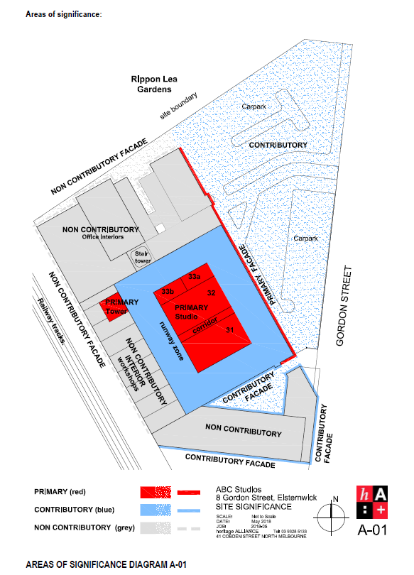

Photos:
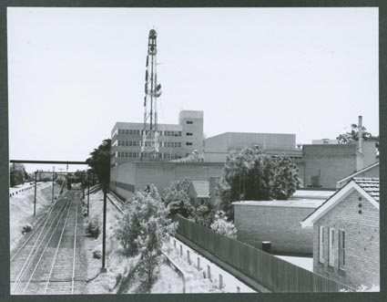
Stage 4 completed, along Sandringham Railway line, showing 4 storey office block and workshop area with Tower above, and the Elsternwick Police station to the far right, circa 1968. National Archives of Australia

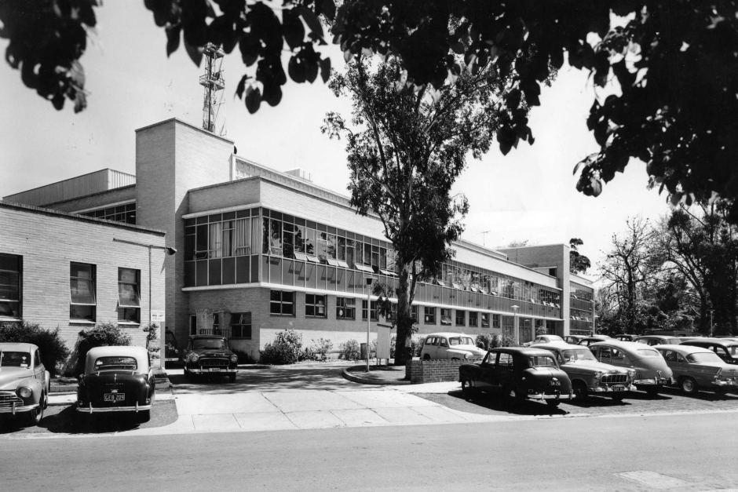
Stages 1, 2 and 3 completed circa 1961. Source http://www.abv2.net.au

Primary Source:
Heritage Assessment – ABC TV Studios, 8 Gordon Street, June 2008

The Canberra Times, ACT, Thursday 4 February 1965, p.13
Louisa Jones, Culture Victoria website https://cv.vic.gov.au/stories/built-environment/rippon-lea-estate/louisa-jones/
Parliament of Victoria website, 1956 Olympics; www.parliament.vic.gov.au/component/jdownloads/download/36-research-papers/13610-2016-3-olympics-hn
Office memo, ABC former staff online archive at http://www.abv2.net.au/office.php
http://www.televisionau.com/
June 9 2011, David Knox https://tvtonight.com.au/2011/06/abc-promises-new-melbourne-tv-studio.html
Natasha Johnson, 23 November 2017 “Dream Factory” farewelled as 60 years of TV production at Ripponlea studios comes to an end.” http://www.abc.net.au/news/2017-11-30/abc-ripponlea-studio-farewelled-end-of-an-era-in-australian-tv/9052728

