Planning and Environment Act 1987

Glen Eira PLANNING SCHEME

AMENDMENT C181

PLanning permit application GE/PP-31418/2017

EXPLANATORY REPORT

Who is the planning authority?
This amendment has been prepared for Glen Eira City Council who is the planning authority for this amendment.
The amendment has been made at the request of the Shelford Girls’ Grammar School.

Land affected by the amendment
The amendment is a combined planning permit application and planning scheme amendment under section 96A of the Planning and Environment Act 1987.
The permit application applies to the land known as 259 Glen Eira Rd, Caulfield North (Lot 3 LP6946).
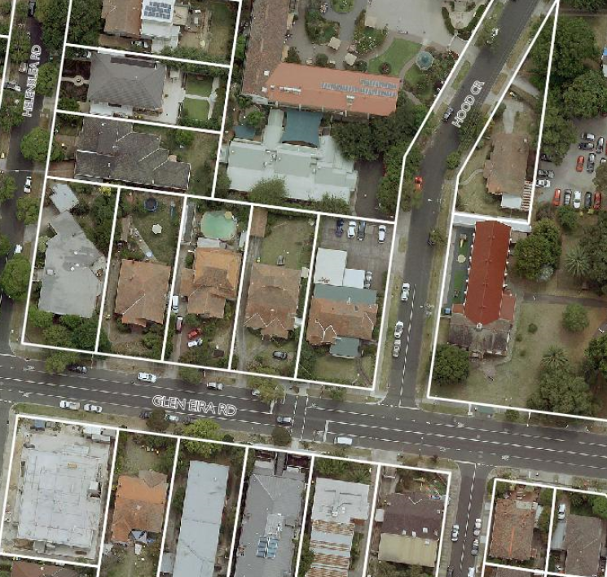

What the amendment does
The amendment seeks to amend the Schedule to Clause 52.02 (Easements, Restrictions and Reserves) to vary the covenant applicable to the subject site.
The amendment seeks to vary the part of the covenant which stipulates that the owner of the land must not:
“erect or allow to be erected on the said Lot Three (Lot 3 being the subject site) or any part thereof of any building other than one private dwelling with a roof of slate tile or other material except iron at a cost of not less than FIVE HUNDRED POUNDS (inclusive of the cost of outbuildings)”.
by inserting the following requirement:
After the words “erect or allow to be erected on the said Lot Three or any part thereof of any building other than one private Dwelling with a roof of slate tile or other material except iron at a cost of not less than FIVE HUNDRED POUNDS (inclusive of the cost of outbuildings)” insert the words “except that the said Lot Three may be developed and used generally in accordance with planning permit no. GE/PP-31418/2017.”
The planning permit application seeks approval for:
- Development and use of land for the purpose of an Education Centre, reduction of the car and bicycle parking requirements, display of a business identification sign and alteration of access to a road in a Road Zone Category 1.
The draft planning permit is attached as a separate document to this Explanatory Report.

Strategic assessment of the amendment

Why is the amendment required?
The amendment is required to facilitate the expansion of Shelford Girls’ Grammar School and allow the use and development of the land in a manner that is consistent with the strategic context and changing characteristics of the area.
The proposed use and development is currently prohibited by the restrictive covenant on the land title. The covenant was created by a transfer of land (Instrument No. 0888051) dated 14 April 1919 and restricts the use and development of the land at 259 Glen Eira Road:
- To not more than one private dwelling;
- To use of building materials for the roof of slate, tile or other material except iron;
- To ensure the erection of the dwelling costs no less than 500 pounds inclusive of the costs of outbuildings.
Variation of this covenant to allow the proposed development specifically will ensure that the land is development in accordance with the draft planning permit conditions and advertised plans that form part of this planning scheme amendment.

How does the amendment implement the objectives of planning in Victoria?
The amendment implements the following objectives contained in Section 4 of the Planning and Environment Act 1987:
a) to provide for the fair, orderly, economic and sustainable use, and development of land;
c) to secure a pleasant, efficient and safe working, living and recreational environment for all Victorians and visitors to Victoria;
f) to facilitate development in accordance with the objectives set out in paragraphs (a), (b), (c), (d) and (e);
g) to balance the present and future interests of all Victorians

It is considered that the amendment will implement the objectives of Planning in Victoria as:
- It is consistent with the principles of orderly and proper planning to vary a restrictive covenant that is no longer consistent with the desired planning outcomes for the land as set out in the applicable planning scheme.
- The restrictive covenant would unreasonably limit the use and development of the land for an education facility which has been assessed in terms of its planning merits by Council.
- The amendment would further the objectives of planning in Victoria and provide for net community benefit.

How does the amendment address any environmental, social and economic effects?
The variation of the covenant would be consistent with the overarching goal in the planning scheme to:
Integrate relevant environmental, social and economic factors in the interests of net community benefit and sustainable development.
The amendment is expected to have positive economic and social effects by enhancing the ability of the school to facilitate the further expansion of a curriculum that specifically promotes STEAM (Science, Technology, Engineering, Arts and Mathematics).
The proposed site is an efficient and effective use of existing infrastructure given it adjoins the main school premises. It is located on a main road close to public transport and other facilities in the community thereby making more efficient use of nearby infrastructure.
The amendment is not expected to have any significant impacts on the environment.

Does the amendment address relevant bushfire risk?
The land affected by the amendment is not located within an area of identified bushfire risk.

Does the amendment comply with the requirements of any Minister’s Direction applicable to the amendment?
The amendment is consistent with the Ministerial Direction on the Form and Content of Planning Schemes under section 7(5) of the Planning and Environment Act 1987.
The amendment has also been prepared with regard to Ministerial Direction No. 9 – Metropolitan Planning Strategy, which refers to Plan Melbourne 2017-2050. Plan Melbourne 2017-2050 identifies a vision for the future of Melbourne. It provides objectives and outcomes sought for the city, with directions identified to achieve the desired outcomes and objectives. The amendment is consistent with the following outcomes and directions within Plan Melbourne 2017-2050:
- Outcome 5 – Melbourne is a city of inclusive, vibrant and healthy neighbourhoods
- Direction 5.3 – Deliver social infrastructure to support strong communities
‘Social infrastructure encompasses all the facilities, services and networks that help families, groups and communities to meet their social, health, education, cultural and community needs’.
- Policy 5.3.2 Create health and education precincts to support neighbourhoods
All neighbourhoods need good access to local and regional health services, primary and secondary schools, as well as tertiary education institutions within their metropolitan region.
This policy promotes the provision of public health and education precincts. Shelford Girls’ Grammar School complements this objective as it consolidates and supports its historic role of education in the Caulfield North neighbourhood.
The facilitation of the new building directly adjoining the school premises will consolidate the school’s role in the provision of education opportunities in close proximity to public transport, services and other infrastructure.
Ministerial Direction No. 11- Strategic Assessment of Amendments requires that a planning scheme amendment adequately addresses relevant planning policy. The amendment is consistent with the relevant policy as described through this report.
Ministerial Direction No. 15 – the Planning Scheme Amendment process, which sets times for completing steps in the amendment process, will be followed during the amendment process.

How does the Amendment support or implement the State Planning Policy Framework and any adopted State policy?
The amendment is consistent with the Planning Policy Framework (PPF) of the Glen Eira Planning Scheme and implements relevant objectives of the Planning Policy Framework (PPF) including:
- Clause 11 – Settlement
Planning is to anticipate and respond to the needs of existing and future communities through provision of zoned and serviced land for housing, employment, recreation and open space, commercial and community facilities and infrastructure.
The proposed amendment seeks to vary the covenant on the title to facilitate the enhancement of education services provided by Shelford Girls’ Grammar School. It addresses the community need for excellence in education facilities servicing the neighbourhood as well as the wider community.
- Clause 15 – Built Environment and Heritage
Planning should ensure all land use and development appropriately responds to its surrounding landscape and character, valued built form and cultural context.
Planning must support the establishment and maintenance of communities by delivering functional, accessible, safe and diverse physical and social environments, through the appropriate location of use and development and through high quality buildings and urban design.
Planning should promote development that is environmentally sustainable and should minimise detrimental impacts on the built and natural environment.
The proposed amendment facilitates use and development that addresses the community aspirations and cultural identity of the area. This includes having a variety of high quality education establishments which contribute to the local urban character.
- Clause 15.01-2S Building design
To achieve building design outcomes that contribute positively to the local context and enhance the public realm.
The proposed amendment will facilitate the development of Shelford Girls’ Grammar School’s facilities by enabling the construction of a building of a high architectural quality that complements the changing streetscape of the area.
- Clause 15.01-5S Neighbourhood character
To recognise, support and protect neighbourhood character, cultural identity, and sense of place.
Shelford Girls’ Grammar School has been a part of the local cultural context of Caulfield North since 1898. Through the variation to the existing covenant, the proposed school building will provide a main road presence for the school with a Glen Eira Road frontage.

How does the Amendment support or implement the Local Planning Policy Framework, and specifically the Municipal Strategic Statement?
Council’s Municipal Strategic Statement sets out Council’s strategic direction for future land use planning and development. A vital element in shaping the vision for the City of Glen Eira is Council's strategic direction:
- Clause 21.01 Municipal Profile
Council recognises the advantage to the municipality in having an excellent range of education and health and community facilities.
- Clause 21.03-5 Framework plan
In terms of institutional and non-residential land uses, the site is considered to be appropriate for a school as it consolidates the presence of the school and provides a main road frontage which is supported by Council policy.
- Clause 21.08 Institutional and Non-Residential Uses in Residential Areas
The amendment supports the integration of non-residential uses into a residential zone with a building of an appropriate scale that will not cause an unreasonable reduction in residential amenity.
- Clause 22.02 Non Residential Uses In Residential Zones Policy
The amendment will enable the development of a high quality classroom building that is in a preferred location and has been designed and sited to minimise residential amenity impacts.
- Clause 22.08 Minimal Change Area Policy
The amendment to vary the covenant and facilitate the development and use of Shelford Girls’ Grammar School complements Council’s policy to retain the existing low intensity, low-rise built form character typical for a Minimal Change Area. The development of a two-storey building on a congenital lot retains the existing subdivision pattern and spacing of buildings typical for the Glen Eira Road streetscape.
- Activity Centre, Housing and Local Economy Strategy
In July 2017, Council adopted the Activity Centre, Housing and Local Economy Strategy. The strategy sets a new vision for the city, which provides a new activity centres framework and direction for place-making, local economy and housing. A relevant component of the strategy is the local economy and providing employment opportunities in the education sector. The proposal is considered consistent with relevant objectives of the strategy including:
- Objective 2.1 – More local jobs – less commuting (given this education facility’s location on a transport corridor).
- Objective 3.2 – Respect Amenity and Local Character (the low-scale design and use).

Does the amendment make proper use of the Victoria Planning Provisions?
It is considered that the amendment makes proper use of the Victoria Planning Provisions. Clause 52.02 (Easements, Restrictions and Reserves) provides a mechanism by which restrictive covenants can be removed or varied and this amendment proposes to utilise this provision.

How does the amendment address the views of any relevant agency?
The views of any relevant agency will be addressed through the amendment process.

Does the amendment address relevant requirements of the Transport Integration Act 2010?
The proposed amendment will not have a significant impact on the transport system and there are no applicable statements of policy principles under Section 22 of the Transport Integration Act 2010.

Resource and administrative costs

What impact will the new planning provisions have on the resource and administrative costs of the responsible authority?
The amendment will not have a substantial impact on the resources and administrative costs of the Responsible Authority.

Where you may inspect this Amendment
The amendment is available for public inspection, free of charge, during office hours at the following places:
Glen Eira City Council
Corner Glen Eira and Hawthorn Roads
Caulfield VIC 3162, and
On the Glen Eira City Council website; www.gleneira.vic.gov.au: and
The amendment can also be inspected free of charge on the Department of Environment, Land, Water and Planning website at www.delwp.vic.gov.au/public-inspection.

Submissions
Any person who may be affected by the amendment and/or planning permit application may make a submission to the planning authority. Submissions about the amendment and/or planning permit must be received by 24 December 2018.
A submission must be sent to:
Urban Planning Department
Glen Eira City Council
PO Box 42
Caulfield South VIC 3162; or
mail@gleneira.vic.gov.au

Panel hearing dates
In accordance with clause 4(2) of Ministerial Direction No.15 the following panel hearing dates have been set for this amendment:
- Directions hearing: To commence in the week of Monday, 1 April 2019;
- Panel hearing: To commence in the week of Monday, 22 April 2019

